jktdh; mPp ek/;fed fo|ky; cwckuh
fo|ky; fodkl ;kstuk 2022&23
¼vkxkeh 3 l=] 2023&24] 2024&25 ,oe~ 2025&26 gsrq½

izi= & 01 % xzke fooj.k %
okl LFkku dk uke % cjM+k cwckuh | xzke dk uke % cwckuh
okMZ la[;k % 7 | xzke iapk;r % cwckuh
CykWd dk uke % vtesj xzkeh.k ¼uoxfBr½ | rglhy % vtesj
ftyk % vtesj | fo/kkulHkk {ks= % iq"dj
lalnh; {ks= % vtesj | jkT; % jktLFkku
okMZiap % Jh cyohj eywdk | ljiap % Jhefr tlksnk es?koa’kh
laLFkkiz/kku % lqJh eydk c{k | SMC v/;{k % Jh fc’ku flag jkor

Tkux.kuk ds vk/kkj ij xzke dh tula[;k % vk/kkj 2021 tux.kuk
dqy tula[;k |  |  | vuqlwfpr tkfr dh la[;k |  |  | vuqlwfpr tutkfr dh la[;k
dqy | iq#"k | efgyk | dqy | iq#"k | efgyk | Dqy | iq#"k | efgyk
3465 | 1796 | 1699 | 347 | 189 | 158 | 0 | 0 | 0
https://studywithrsm.com/
xzke dk laf{kIr bfrgkl
f’k{kk ds {ks= es u dsoy jktLFkku vfirq Hkkjro"kZ viuk egRo j[kus okyk vtesj uxj tks fgUnw o eqfLye /kekZoyfEc;ksa dk /kkÆed LFkku Hkh gS tgka gtjr [oktk eksbuqÌhu fp’rh dh fo’o izflö njxkg gS] ogh bl uxj ds fudV iq"dj esa txn~izflö fo’o dk ,d ek= czãk efUnj Hkh gS rFkk vk;Z lekt ds laLFkkid Lokeh n;kuUn ljLorh dh fuokZ.k LFkyh Hkh gSA

,sls uxj dh ân;LFkyh ds lehi t;iqj ekxZ ij xxokuk dLcs ls iwoZ fn’kk es 9 fd-eh- nwj [kksMk x.ks’k efUnj ls igys xzke cwckuh fLFkr gSA ;g xzke fd’kux< ls Hkh lkehI; j[krk gS blfy, vf/kdka’k xzkeoklh mPp f’k{kk ]thodksikZtu ] fpfdfRlk ds fy, fd’kux< tkrs gSA ;gka dh tula[;k eq[;r% etnwj oxZ gS A d`f"kdk;Z ] iRFkjks dk [kuu ] ekcZy QSDVªh ] dkap QSDVªh ] Mªkbfoax bR;kfn eq[; O;olk; gSA

fo|ky; dk bfrgkl

jktdh; mPp ek/;fed fo|ky; cwckuh dh LFkkiuk 1950 es izkFkfed Lrj ij gqbZA ;g fo|ky; 1986 esa mPp izkFkfed Lrj ,oa 2005 es ek/;fed Lrj ij rFkk 2015 es mPp ek/;fed Lrj ij ØeksUur gqvkA 2014 es ,dhdj.k ds i’pkr orZeku es d{k 1 ls 12 lapkfyr gSA jkT; ljdkj dh egRodka{kh vkn’kZ fo|ky; ;kstuk ds vUrxZr fo|ky; dk p;u fd;k x;k gSA fo|ky; fujUrj fodkl dh vksj vxzlj gSA l= 2021& 22 es fo|ky; dk p;u ftyk Lrj ij loZJs"B fo|ky; ds :Ik es gqvk gSA xzke iapk;r eq[;ky; ij vofLFkr mPp ek/;fed fo|ky; gksus ls fo|ky; ds laLFkk iz/kku dks ihbZbZvks ¼iapk;r izkjfEHkd f’k{kk vf/kdkjh½ ds :i esa xzke iapk;r {ks= esa vofLFkr izkFkfed ,oe~ mPp izkFkfed fo|ky;ksa dh ekWuhVfjax rFkk osru vkgj.k&forj.k lfgr 'kSf{kd iz’kkldh; dk;Z Hkh nkf;RokUrxZr fuoZfgr g
https://studywithrsm.com/

73 o"khZ; esjk fo|ky; % ,d ut+j esa
1 | izkFkfed fo|ky; LFkkiuk | 1950 | 6 | fo|ky; ;w&Mkbl dksM | 08210304901
2 | mPp izkFkfed fo|ky; ØeksUur o"kZ | 1986 | 7 | fo|ky; dk ,u-vkbZ-lh- ,l-Mh- vkbZ-Mh- | 214253
3 | ek/;fed fo|ky; ØeksUur o"kZ | 2005 | 8 | fo|ky; dk Mh-Mh-vks- dksM | 15814
4 | mPp ek/;fed fo|ky; ØeksUur o"kZ | 2015 | 9 | fo|ky; dk v{kka'k | 26.5200°N
5 | vc rd dk vfUre izos’kkad | 2238 | 10 | fo|ky; dk ns'kkUrj | 74.7981°E

fo|ky; ifj{ks= esa lapkfyr ldy f’k{kk lqfo/kk laLFkku
jktdh; | xSjjktdh; | iwoZizkFkfed
jk-m-ek-fo- cwckuh | f’ko efgek m-izk-fo-cwckuh | vkaxuckMh 1] 2] 3 cwckuh
jk-m-ek-fo- eqgkeh | Jhjke m-izk-fo- cwckuh | vkaxuckMh 1] 2 eqgkeh
jk-izk-fo- [kksM+k | ’kkjnk Xykscy izk-fo- cwckuh | vkaxuckMh 1 [kksMk
jk-izk-fo- L;kyks dh <k.kh | vHk;jkt m-izk-fo- eqgkeh | iwoZ izkFkfed f’k{kk gsrq dqy 6 vkaxuokM+h
jk-izk-fo- caxyk dh <k.kh | jsfefulsaV m-izk-fo- ewgkeh
https://studywithrsm.com/
fo|ky; ,l Mh ,l ,e lh dk ifjp;

dze la | uke | inuke | ‘’kSf{kd ;ksX;rk | O;olk; | fyax | lEidZ lw=
1 | eydk c{k | v/;{k | ,e- ,- ch -,M- | f’k{kd | efgyk | 9829280990
2 | rstkjke es?koa’kh | vfHkHkkodks es ,llh@,lVh lnL; | 12 ikl | fuft O;olk; | iq:"k | 7891130653
3 | yhyk nsoh | vfHkHkkodks es ,llh@,lVh lnL; | lk{kj | x`fg.kh | efgyk | 7976142256
4 | pkanh nsoh | vfHkHkkodks es ls efgyk | lk{kj | x`fg.kh | efgyk | 9660516123
5 | esFkh nsoh | vfHkHkkodks es ls efgyk | lk{kj | vkaxuckMh lkgf;dk | efgyk | 8003555663
6 | deyfd’kksj | vfHkHkkodks es ls izfrfuf/k | 8 ikl | etnwjh | iq:"k | 7851052946
7 | dks;k nsoh | vfHkHkkodks es ls izfrfuf/k | lk{kj | x`fg.kh | efgyk | 9928502807
8 | o"kkZ ‘’kekZ | dyk oxZ ls O;k[;krk | ,e- ,- ch -,M- | f’k{kd | efgyk | 9314484471
9 | nsosanz dqekj ’kekZ | foKku dk ofj"B v/;kid | ,e,llh ch,M | f’k{kd | iq:"k | 9828737306
10 | lfork dqekor | xf.kr dk ofj"B v/;kid | ch,llh ch,M | f’k{kd | efgyk | 8619894201
11 | vfurk jkor | iapk;r lnL; izfrfuf/k | lk{kj | x`fg.kh | efgyk | 8302035004
12 | lksfguh nsoh | iapk;r lnL; izfrfuf/k | lk{kj | x`fg.kh | efgyk | 9694686733
13 | vfer Vkad | laLFkk dk ys[kk dkÆed | ch,llh | dfu"B lgk;d | iq:"k | 7737356517
14 | egsanz eh.kk | fo|ky; fodkl es Hkkxhnkj | 8 ikl | fuft O;olk; | iq:"k | 9950794913
15 | xk;=h nsoh | efgyk lewg lnL; | 8 ikl | vkaxuckMh dk;ZdrkZ | efgyk | 9983009536
16 | gseyrk tslokuh | f’k{kk fo) | ,e- ,- ch -,M- | f’k{kd | efgyk | 9602325240
17 | nyhi f<yk.k | ftyk ifj;kstuk }kjk euhfur lnL; | ch-,- ch-,M | f’k{kd | iq:"k | 9049478550
18 | t; izdk’k ‘’kekZ | ftyk f’k{kk vf/kdkjh }kjk euksfur | ,e- ,- ch -,M- | iz/kkukpk;Z | iq:"k | 9460355511
19 | y{eh jkor | fo|kFkhZ izfrfuf/k | 12 v/;;ujr | fo|kFkhZ | efgyk
20 | fodze eywdk | fo|kFkhZ izfrfuf/k | 12 v/;;ujr | fo|kFkhZ | iq:"k | 9929679488
21 | panzizdk’k dqekor | fo/kk;d izfrfuf/k | 12 ikl | fuft O;olk; | iq:"k | 9828044812
22 | Qwyflag jkor | fo/kk;d izfrfuf/k | 10 ikl | fuft O;olk; | iq:"k | 9694686733
23 | ubeqíhu | lfpo | ,e- ,- ch -,M- | f’k{kd | iq:"k | 9667351649

https://studywithrsm.com/
fo|ky; ,l ,l ,e lh dk ifjp;

dze la | uke | inuke | ‘’kSf{kd ;ksX;rk | O;olk; | fyax | lEidZ lw=
1 | fc’ku flag | v/;{k | 12 ikl | fuft O;olk; | iq:"k | 9610329186
2 | e/kqyrk | mik/;{k | lk{kj | x`fg.kh | efgyk | 7976548777
3 | y{eh | efgyk lnL; | 10 ikl | x`fg.kh | efgyk | 9664401290
4 | lUuq | efgyk lnL; | lk{kj | x`fg.kh | efgyk | 9694051375
5 | fiadh | efgyk lnL; | 12 ikl | x`fg.kh | efgyk | 9828044815
6 | lhek | efgyk lnL; | 9 ikl | x`fg.kh | efgyk | 9694093070
7 | eksuk | efgyk lnL; | 3 ikl | x`fg.kh | efgyk | 8306525588
8 | x.ks’k es?koa’kh | iq:"k lnL; | 8 ikl | etnwjh | iq:"k | 8890785084
9 | esok flag | iq:"k lnL; | 8 ikl | etnwjh | iq:"k | 9887960008
10 | izdk’k jkor | iq:"k lnL; | 9 ikl | etnwjh | iq:"k | 7023993078
11 | dku flag | iq:"k lnL; | 5 ikl | etnwjh | iq:"k | 6367232248
12 | cyohj eywdk | insu lnL; | 10 ikl | etnwjh | iq:"k | 7976142256
13 | eydk c{k | insu lnL; lfpo | ,e- ,- ch -,M- | f’k{kd | efgyk | 9829280990
14 | dYiuk pkSgku | fuokZfpr v/;kid | ,e- ,- ,lVhlh | f’k{kd | efgyk | 8005601160
15 | eksgu flag jkor | euksfur lnL; | 8 ikl | fuft O;olk; | iq:"k | 9829296697
16 | lksguyky ea?koa’kh | euksfur lnL; | 12 ikl | fjVk;j iksLVesu | iq:"k | 9413148265
https://studywithrsm.com/

fo|ky; ekuo lalk/ku ifjp;
Øe | uke | inuke | fo"k; | ;ksX;rk |  | lEidZ lw= | Lksok fuo`fRr
 |  |  |  | 'kSf{kd | iz'kSf{kd
1 | Miss Malka Bux | Principal & Equivalent | N/A | B.A., M.A.(Economics) | B.Ed. | 98292-80990 | Jul-2029
2 | Naimuddin | Lecturer (I Gr.) | Hindi | B.A., M.A. (Hindi, Urdu, History) | B.Ed. | 96673-51649 | Oct-2046
3 | Varsha Sharma | Lecturer (1Gr) | Pol Sc | B.A. M.A. (Pol Sc) | B.Ed | 93144-84471 | Oct-2030
4 | Dalip Kumar Dhillan | Senior Teacher(Gr2) | Hindi | BAM.A( Geography) | B.ED | 90497-88550 | Dec-2042
5 | Devendra Kumar Sharma | Senior Teacher (Gr 2) | Science | B.Sc , M. Sc(Chemistry, Geography) | B.Ed | 98287-37306 | Oct-2042
6 | Savita Kumawat | Senior Teacher ( Gr 2 ) | Maths | B.Sc. | B.Ed | 80033-91800 | Nov-2043
7 | Shivali Sharma | Senior Teacher ( Gr 2) | Sanskrit | B.A. M.A. (Sanskrit) | B.Ed | 89499-68186 | June-2048
8 | Sunita Meena | Teacher (Gr 3) L2 | Hindi | B.A.M.A.(History, Hindi) | B.Ed | 80588-09408 | June-2046
9 | Dinesh Kumar Jangid | Teacher (Gr 3) L2 | English | B.A. | B.Ed | 80588-57558 | July- 2040
10 | Hemlata Jeswani | Teacher (Gr 3) L2 | Scsial Studies | B.A.M.A. (Hindi) | B.Ed | 96642-74577 | Feb-2029
11 | Kanhaiyalal Bairwa | Teacher (Gr 3) L1 | All Sub | Sr.Sec. | BSTC | 99504-26004 | June- 2032
12 | Kalpana Chouhan | Teacher (Gr 3) L1 | All Sub | B.A.M.A.(Hindi) | BSTC | 82908-25187 | July- 2033
13 | Kiran Yadav | Teacher (Gr 3) L1 | All Sub | B.A. | B.Ed | 63757-94677 | July- 2047
14 | Shameem Bano | PTI ( Gr 3) | Health Edu. | B.A. | C.P.Ed | 79766-71491 | Jan- 2037
15 | Amit Gaur | Senior Assistant | N/A | B.A. | --- | 94602-74001 | Jan- 2022
16 | Amit Tak | Junior Assistant | N/A | B.Sc | --- | 77373-56517 | June-2047
17 | Manish Chouhan | IV Class | N/A | 8th | --- | 92149-86014 | June- 2040
18
19
20

fo|ky; dks orZeku l= esa lexz f’k{kk ls izkIr fofo/k vuqnku ,oe~ mi;ksx
Øe | vuqnku dk fooj.k |  |  |  | mi;ksx leh{kk |  |  | vkxkeh y{; |  |  | fo-fo-
 | uke vuqnku | vuqnku vk/kkj | jkf'k | HkkSfrd | Oct-22 | Feb-23 | Mar-23 | 2023-24 | 2024-25 | 2025-26
1 | CSG Grant | UDISE-2020-21 | 75,000 | 717 | 50% | 70% | 100% | 75,000 | 75,000 | 100,000
2 | CRC Grant | PEEO | 22,000 | PS-UPS | 50% | 70% | 100% | 22,000 | 22,000 | 22,000
3 | STARS SDMC-SMC | PEEO per School | 15,780 | 2 | 0% | 100% | --- | 15,780 | 15,780 | 15,780
4 | STARS SDMC-SMC | Per School | 5,000 | 1 | 0% | 100% | --- | 5,000 | 5,000 | 5,000
5 | Sports Grant | Per School | 25,000 | 1 | 0% | 100% | --- | 25,000 | 25,000 | 25,000
6 | CTS Grant | Enrollment Rs.3/- | 2,151 | 717 | 0% | 100% | ---
7 | Youth & Eco Club | Per School | 15,000 | 1 | 0% | 100% | ---
8 | CM - Community Awareness | Per School | 300 | 1 | 0% | 100% | ---
9 | CM - Aapni Laado | Per School | 200 | 1 | 0% | 100% | ---
10 | CM - Baal Samaroh | Per School | 200 | 1 | 0% | 100% | ---
11 | Volunteers Training | Per School | 640 | 1 | 0% | 100% | ---
12 | SMC-SDMC Members Training | Per School | 3,000 | 1 | 0% | 100% | ---
13 | SMC-SDMC Members Training | PEEO per School | 15,000 | 5 | 0% | 100% | ---
14 | Kishori Mela | Per School | 2,250 | 1 | 100% | --- | ---
15 | Kishori Mela | PEEO per School | 4,500 | 2 | 100% | --- | ---
16 | RLARP Self Defence | Per School | 5,000 | Elem | 0% | --- | ---
17 | RLARP Self Defence | PEEO per School | 5,750 | Sec | 100% | --- | ---
18 | Cyber Security | Per School | 500 | 1 | 0% | 100% | ---
19 | School Safety Flex | Per School | 1,000 | 1 | 0% | 100% | ---
20 | Ek Bharat Shreshtha Bharat | Per School | 500 |  | 0% | 100% | ---
21 | Rural Olympic | PEEO | 9,150 | 1 | 100% | --- | ---
22 | STARS - Model Green School | Enrollment | 0 |  |  |  |  | 15,000 | 15,000 | 15,000
23 | Transport Voucher 1-8 |  |  | 47 | 0% | 50% | 50%
24 | Transport Voucher 9-12 (Girls) |  | 0 | 0 | 0 | 0 | 0
25 | IED - Escort Allowane | No of eligible students
26 | IED - Transport Allowance | No of eligible students
27 | IED - Reader Allowance | No of eligible students
28 | IED - Stipend (for Girls) | No of eligible students
29 | STARS - Holistic Development | for Elem. Setup only
30 | TAF PINDICS | Rs.50/- per staff
31 | LEP - Remedial Teaching (9-12)
32 | Cluster Level Mentor Teacher Training | As per Mentors
33 | STARS AWW/Teachers Training
34 | Shala Siddhi
35 | KGBV Nodal Grant
36 | Early Childhood Care & Education
37 | CCE - Teacher Support Material
38 | VE - Exposure (6-8)
39 | VE - Spoke & Hub New
40 | VE - Vocational
41 | Cyber Security
42 | Cyber Security
43 | Fund for Safety & Security
44 | VE - Spoke & Hub Old
45 | VE - OoSC Training
46 | VE - CWSN
47
48
49
50
Total
izi= &02 % fo|ky; ifj{ks= es dqy ukekadu
vk;q oxZ | ckyd | ckfydk | ;ksx
0&3 | 71 | 64 | 135
4&5 | 75 | 76 | 151
6&14 | 343 | 313 | 656
15&18 | 139 | 114 | 253
;ksx | 628 | 567 | 1195

fo|ky; es v/;;ujr oxZokj fo|kÆFk;ksa dh la[;k%
Class | Gen | ST | SC | OBC | SBC | Total | Min | CWSN
1st | 0 | 1 | 8 | 26 | 0 | 35 | 0
2nd | 0 | 1 | 6 | 36 | 0 | 43 | 0
3rd | 0 | 1 | 13 | 29 | 0 | 43 | 0
4th | 0 | 0 | 8 | 36 | 0 | 44 | 0
5th | 0 | 0 | 9 | 39 | 0 | 48 | 0
6th | 0 | 1 | 17 | 61 | 0 | 79 | 0
7th | 0 | 0 | 10 | 53 | 3 | 66 | 0
8th | 1 | 1 | 9 | 51 | 1 | 63 | 0
9th | 0 | 1 | 10 | 69 | 2 | 82 | 0
10th | 0 | 1 | 5 | 65 | 0 | 71 | 0
11th | 2 | 1 | 8 | 42 | 0 | 53 | 0
12th | 0 | 0 | 7 | 72 | 6 | 85 | 0
Total | 3 | 8 | 110 | 579 | 12 | 712 | 0
izi= &03 % v/;kid vko’;drk vkdyu izi=%
- izkFkfed Lrj ekun.M %
60 cPpksa rd % 2 v/;kid] 60 ls 90 ds e/; % 3 v/;kid
91 ls 120 ds e/; % 4 v/;kid 121 ls 200 ds e/; % 5 v/;kid
Ø la | ukekadu | orZeku es dk;Zjr | ekun.Mkuqlkj f’k{kdks dh vko’;drk | vko’;drk | vf/kd
1 | 213 | 3 | 6 | 3 | 0
- mPp izkFkfed Lrj ekun.M %
de ls de izfr d{kk ,d f’k{kd fuEu fo"k; ds fy,] foKku @xf.kr & 1] lk-foKku&1] Hkk"kk&1 ¼fganh@vaxzsth@laLd`r½
izR;sd 35 ckydks ds fy, de ls de ,d f’k{kd
Ø la | ukekadu | orZeku es dk;Zjr |  |  | ekun.Mkuqlkj f’k{kdks dh vko’;drk |  |  | vko’;drk | vf/kd
 |  | xf.kr@ foKku | Lkk-foKku | Hkk"kk | xf.kr@ foKku | Lkk-foKku | Hkk"kk
1 | 208 | 0 | 1 | 2 | 2 | 1 | 2 | 2 | 0
- ek/;fed fo|ky; Lrj%
Ø la | ukekadu | orZeku es dk;Zjr |  |  | ekun.Mkuqlkj f’k{kdks dh vko’;drk |  |  | vko’;drk | vf/kd
 |  | xf.kr@ foKku | lkfoKku | Hkk"kk | xf.kr@ foKku | Lkk-foKku | Hkk"kk
1 | 153 | 2 | 0 | 2 | 2 | 1 | 2 | 0 | 0

- mPp ek/;fed Lrj %
Ø la | ukekadu | orZeku es dk;Zjr |  |  |  | ekun.Mkuqlkj f’k{kdks dh vko’;drk |  |  |  | vko’;drk | vf/kd
 |  | oSdfYid  fo"k; | vfuok;Z  fo"k; | iz/kkukpk;Z | miizkpk;Z | oSdfYid  fo"k; | vfuok;Z  fo"k; | iz/kkukpk;Z | miizkpk;Z
1 | 138 | 2 | 0 | 1 | 0 | 3 | 2 | 1 | 1 | 4 | 0
izi= &04 % ’kSf{kd mUu;u
Ø la | xfrfof/k | orZeku fLFkfr | y{; | le;kof/k ftles iw.kZ gksuk gS | iw.kZ djus gsrq lg;ksx | ftEesnkjh | izxfr leh{kk |  | vkxkeh 3 l=ksa dk y{;
 |  |  |  |  |  |  | flrEcj 23 | Qjojh 23 | 2023-24 | 2024-25 | 2025-26
1 | fo|ky; ukekadu | 729 | 800 | flrEcj | vfHkHkkod] tuizfrfuf/k] SDMC /SMC lnL;x.k ,oa okWysf.V;lZ | leLr fo|ky; LVkQ | 700 |  | 802 | 882 | 970
2 | fo|ky; ifj{ks= dk dqy ukekadu | 1195 | 1280 | flrEcj |  | ifj+{ks= ds leLr fo|ky; LVkQ |  |  | 1315 | 1447 | 1592
3 | Bgjko | 90% | 100% | l=kar |  |  | 100% |  | 100% | 100% | 100%
4 | mifLFkfr | 80% | 100% | l+=kar |  | leLr fo|ky; LVkQ |  |  | 100% | 100% | 100%
5 | cPpks dk ’kSf{kd Lrj d{kk ds vuq#i ykuk | 50% | 100% | l+=kar |  |  | 60% |  | 100% | 100% | 100%
6 | foKku xf.kr fdV dk mi;ksx | 70% | 100% | l=kar | & | lacaf/kr fo"k; v/;kid | 80% |  | 100% | 100% | 100%
7 | Uks’kuy vphoes.V losZ esa Js"Brj izn’kZu

izi+= &05 % lg ’kSf{kd mUu;u
Ø la | xfrfof/k | orZeku fLFkfr | y{; | le;kof/k ftles iw.kZ gksuk gS | iw.kZ djus gsrq lg;ksx | mRrjnkf;Ro | izxfr leh{kk |  | vkxkeh y{;
 |  |  |  |  |  |  | flr-&23 | fnl-&23 | 2023-24 | 2024-25 | 2025-26
1 | izkFkZuk lHkk | fu;fer | vf/kd jkspd cukuk | l=kar | leLr v/;kid x.k o Nk= ifj"kn | lnu izHkkjh ’kkfjfjd f’k{kd lkaLd`frd ea=h | 100% | 100% | 100% | 100% | 100%
2 | LoPNrk o LokLF; dk;ZØe | fu;fer tkap] vk;ju xksyh forj.k] dksfoM oSfDlu gkFk /kqykbZ fnol | LoLFk fo|kFkhZ | l=kar | leLr v/;kid x.k o Nk= ifj"kn | ,,u,e vk’kk lg;ksfxuh ’kkfjfjd f’k{kd | 100% | 100% | 100% | 100% | 100%
3 | fu;fer [ksydwn | fQV bafM;k dk;Zdze dk vk;kstu fu;fer [ksydwn djk, tkrs gS | ftyk o jkT; Lrjh; izfr;ksfxrk es Hkkxhnkjh c<+kuk o ftyk jkT; Lrj ij fo|kÆFk;ksa dk p;u | f'fojk iapkaxkuqlkj |  | ckylHkk izHkkjh ’kkfjfjd f’k{kd | 60% | 100% | 100% | 100% | 100%
4 | ckylHkk | dksfoM izksVksdky ds dkj.k LFkfxr | ikposa ’kfuokj dks vk;kstu | l=kar |  | ckylHkk izHkkjh ’kkfjfjd f’k{kd lkaLd`frd ea=h | 100% | 100% | 100% | 100% | 100%
5 | jk"Vªh; ioksZ dk vk;kstu | vk;ksftr fd, tkrs gS | 15 vxLr 2 vDVwcj 26 tuojh ij lekjksg vk;ksftr djuk | f'kfojk iapkaxkuqlkj |  |  | 66% | 100% | 100% | 100% | 100%
6 | lkfgfR;d lkaLd`frd xfrfof/k;ka | vk;ksftr fd, tkrs gS | leLr izfr;ksfrkvks es fo|kÆFk;ks dk Hkkx ysuk lqfuf’pr djuk | l=kar |  |  | 100% | 100% | 100% | 100% | 100%
7 | iqLrdky; dk cPpksa }kjk mi;ksx | mi;ksx fd;k tk jgk gS | 50 izfr’kr fo|kÆFk;ksa dks iqLrd forj.k | lkIrkfgd | iqLrdky; es miyC/k iqLrds | d{kk/;kid o iqLrdky; izHkkjh | 100% | 100% | 100% | 100% | 100%
8 | fofHkUu esyks dk vk;kstu | fd;k tkrk gS | fd’kksjh o cky esys dk vk;kstu | f'fojk iapkaxkuqlkj | leLr v/;kid x.k o Nk= ifj"kn | izHkkjh v/;kid leLr v/;kid x.k o Nk= ifj"kn | 50% | 100% | 100% | 100% | 100%
9 | l`tukRed dk;Z | djk, tkrs gS | SUPW & Waste to Best Program& Art edu | l=kar |  |  | 50% | 100% | 100% | 100% | 100%
10 | cLrkeqDr fnol uks cSx Ms | izR;sd ‘’kfuokj dks vk;stu | Fkhe vuqlkj izR;sd ‘’kfuokj dks vk;stu | l=Ik;Zar |  |  | 50% | 100% | 100% | 100% | 100%
11 | xzkeh.k vksyfEid [ksyksa essa lgHkkfxrk | f[kykfM;ksa dk iathdj.k | jkT; ljdkj ds funZs’kkuqlkj vk;kstu djuk | flrEcj 22 |  |  | 100% | ------ | 100% | 100% | 100%
12 | gfjr fo|ky; LoPN fo|ky; | 300 ?kus isM o fdpu xkMZu | uoizos’kh vuqlkj iks/kkjksi.k | flrEcj 22 |  |  | 100% | 100% | 100% | 100% | 100%
13 | fof/kd tkx#drk | fof/kd Dyc dk xBu | fof/kd tkx#drk xfrfo/k;ksa es Hkkx ysuk | iapkaxkuqlkj |  |  | 100% | 100% | 100% | 100% | 100%
14 | pqIih rksM+ks [kqydj cksyks | lapkfyr | funZs’kkuqlkj izR;sd ‘’kfuokj dks l= dk vk;kstu djuk | l=kar |  |  | 100% | 100% | 100% | 100% | 100%
15 | oSLV Vw csLV dckM+ ls tqxkM+ | lapkfyr | IykfLVd cksry ls ltkoV oLrqvksa dk fuekZ.k | xzh"ekodk’k |  |  | 100% | 100% | 100% | 100% | 100%
16 | VkW; dkuZj | miyC/k | vkaxuckMh gsrq f[kykSus | && |  |  | 100% | 100% | 100% | 100% | 100%
17 | Js"B ,l,elh ,lMh,elh | && | jkT; Lrj ij p;u | iapkaxkuqlkj |  |  | && | Cykd Lrj ij p;u | 100% | 100% | 100%
izi= 06 % HkkSfrd lalk/ku
Ø la | fo|ky; izkax.k es Hkou fodkl xfrfof/k | orZeku fLFkfr | dqy vko’;drk | vuqekfur ykxr | izxfr leh{kk |  | izko/kku |  |  | fo’ks"k
 |  |  |  |  | flrEcj 22 | Qjojh&23 | 2023-24 | 2024-25 | 2025-26
1 | Hkou | 2 ifjlj miyC/k | 0 | N/A | && | && | 0 | 0 | 0 | &
2 | iz/kkuk/;kid d{k | miyC/k | 0 | N/A | && | && | 0 | 0 | 0 | &
3 | vfrfjDr d{kk d{k | 12 d{kk d{k | 0 | N/A | && | && | 0 | 0 | 0 | &
4 | ckyd&ckfydkvksa gsrq ty;qDr ’kkSpky; | 5 ckyd 7 ckfydk ’kkSpky; | 0 | N/A | && | && | 0 | 0 | 0 | &
5 | ckfydk ’kSpky; es buflujsVj miyC/krk | miyC/k | 0 | N/A | && | && | 0 | 0 | 0 | &
6 | fo|kfFkZ;ksa ds dn vuqlkj crZu /kksus gsrq flad cuokuk | miyC/k | 0 | N/A | && | && | 0 | 0 | 0 | &
7 | fo|ky; pkjnhokjh | miyC/k | u, ifjlj es ejEer o ÅpkbZ c<kuk | 10 Lacs | 0% |  | ugh | gka | gka | xzke iapk;r es izLrko izsf"kr
8 | fdpu ’ksM | miyC/k | 0 | N/A | && | && | 0 | 0 | 0 | &
9 | is;ty lqfo/kk | V~;wcoSy Vsad okVj dwyj vkjvks | chlyiqj ikbi ykbu | 5 Lacs | 0% |  | gka | gka | gka | vkosnu izsf"kr
10 | fo|kfFkZ;ksa ds dn vuqlkj is;ty VwafV;ka yxokuk | miyC/k | VqVh gqb dks cnyuk | 1 Lac | && | &&
11 | Hkkstu idkus ijkslus ,oa [kkus ls iwoZ lkcqu ls gkFk /kksus dh i;kZIr lqfo/kk | miyC/k | 0 | N/A | && | && | 0 | 0 | 0 | &
12 | izfrfnu lHkh cPpks ds gkFk /kksus gsrq i;kZIr lkcqu dh O;oLFkk | miyC/k | 0 | N/A | && | && | 0 | 0 | 0 | &
13 | fdpu xkMZu fodflr djuk | miyC/k | ekSle vuqlkj lCth mxkuk | 10,000 | 50% | && | 100% | 100% | 100%
14 | xzkl xkMZu fodflr djuk | miyC/k | {ks= c<kuk | 2000 | 0% | && | 100% | 100% | 100%
15 | fctyh lqfo/kk | lksyj o fxzM | 0 | N/A | && | && | 0 | 0 | 0 | &
16 | dEi;wVj d{k | miyC/k | 0 | N/A | && | && | 0 | 0 | 0 | &
17 | iz;ksx’kkyk | miyC/k | 0 | N/A | && | && | 0 | 0 | 0 | &
18 | iqLrdky; | miyC/k | 0 | N/A | && | && | 0 | 0 | 0 | &
19 | jSEi | miyC/k | 0 | N/A | && | && | 0 | 0 | 0 | &
20 | lhMCY;w,l,u VkW;ysV dk fuekZ.k | miyC/k | 0 | N/A | && | && | 0 | 0 | 0 | &
21 | fnO;kax lqfo/kk | miyC/k | jsfyax yxokuk | 1 Lac | 0% | 0% | 0 | 0 | 0 | &
22 | vU; | miyC/k | iqjkus ifjlj es ejEer | 2 Lacs |  |  | 0 | 0 | 0 | &
 | 1 ejEer ,oa j[k j[kko |  |  | 10 Lacs | 0% | 0%
 | 2 Ldwy izca/ku gsrq vko’;d lkexzh | miyC/k | 0 | N/A |  |  | 0 | 0 | 0 | &
 | 3 feM Ms ehy gsrq vko’;d lkexzh | miyC/k | 0 | N/A |  |  | 0 | 0 | 0 | &
 | 4 [ksy eSnku ,oa [ksy lkexzh | miyC/k | 0 | N/A |  |  | 0 | 0 | 0 | &
23 | fo’ksa"k vko’;drk okys cPpks ds fy, midj.k | 0 | 0 | N/A |  |  | 0 | 0 | 0 | &
24 | lhlhVhoh dSejk | 0 | 14 dSejk okyk midj.k | 50,000 |  |  | 0 | 1 | 0 | &
25 | LekVZ Dykl #e gsrq midj.k | 0 | LekVZ cksMZ izkstsDVj lhih;w | 4 Lacs |  |  | 0 | 1 | 0 | eq[;ea=h tulgHkkfxrk }kjk
26 | fo|kÆFk;ksa gsrq QuhZpj | 200 | 600 | 6 Lacs | 250 |  | 400 | 600 | 800 | Tt lg;ksx }kjk

fo|ky; fodkl gsrq lfefr lnL;ksa ls izkIr izLrko
Ø-la- | izLrko la- | fnukad | izLrkod dk uke o in | izLrqr fyf[kr izLrko dk laf{kIr fooj.k | lnL;ksa dh izfrfØ;k@lgefr | izLrko dh fØ;kfUofr | fo-fo-
1
2
3
4
5
6
7
8
9
10
11
12

izi= 07 % lkekftd mUu;u
Ø la | xfrfof/k | orZeku fLFkfr | y{; | le;kof/k ftles iw.kZ gksuk gS | iw.kZ djus gsrq L=ksr | ftEesnkjh@ leUo;d | izxfr leh{kk |  | y{;
 |  |  |  |  |  |  | flrEcj 22 | Qjojh&23 | 2023-24 | 2024-25 | 2025-26
1 | vfHkHkkodks ls fu;fer lEidZ | fu;fer f’k{kd vfHkHkkod cSBd dk vk;kstu fd;k tkrk gS | 100 izfr’kr vfHkHkkodks ls lEidZ o cSBd es mifLFkfr | l=kar | f’k{kd fo|kFkhZ | laLFkkiz/kku | 50 izfr’kr | &
2 | Hkkek’kkgks dh lwph cukdj le; le; ij lEidZ djuk | fd;k tkrk gS lEEkku lekjksg vk;ksftr fd, tkrs gSa | iqjkus o u, Hkkek’kgks ls lEidZ | l=kar | l[kk laxe o iwoZ Nk= lEesyu | laLFkk iz/kku] fo|ky; fodkl izHkkjh] SMC/SDMC lnL; | 50 izfr’kr | &
3 | fofHkUu lkekftd ;kstukvks dh tkudkjh nsuk | PTM SDMC/SMC izkFkZuk lHkk xzkelHkk es tkudkjh nh tkrh gS | 100 izfr’kr Nk=o`fr ikyugkj o vU; ;kstukvks dk ykHk fnyokuk | l=kar | & |  | 50 izfr’kr | &
4 | ifj{ks= ds tuizfrfuf/k;ks ls lEidZ ,oa leUo;u Lfkkfir djuk | okMZiap ljiap fo/kk;d ls fujarj lEidZ fd;k tkrk gS |  | l=kar | & |  | 50 izfr’kr | &

https://studywithrsm.com/

izi= 8 % fo|ky; esa ladk;@fo"k; o`f} gsrq ;kstuk
Ø la | xfrfof/k | orZeku fLFkfr | y{; | le;kof/k ftles iw.kZ gksuk gS | iw.kZ djus gsrq L=ksr | ftEesnkjh@ leUo;d | izxfr leh{kk |  | y{;
 |  |  |  |  |  |  | flrEcj 22 | Qjojh&23 | 2023-24 | 2024-25 | 2025-26
1 | dyk ladk; es vfrfjDr fo"k; | fganh lkfgR;  jktfufr foKku  bfrgkl oSdfYid fo"k; miyC/k | Hkqxksy laLd`r lkfgR; o x`gfoKku fo"k; [kqyokuk | 3 o"kZ | foHkkx | laLFkkiz/kku | 0 | 0 | 100% | && | &&
2 | vU; ladk; | foKku ladk; es :fp okys fo|kFkhZ vU; fo|ky; es izos’k ysrs gSa | foKku ladk; [kqyokuk | 3 o"kZ | foHkkx | laLFkk iz/kku | 0 | 0 | 0 | 100% | &&
3 | O;olkf;d f’k+{kk | lapkfyr ugh | O;olkf;d f’k+{kk pkyw djokuk | vkxkeh l= | SAMSA | ADPC SAMSA @laLFkk iz/kku | 0 | izLrko izf"kr | d{kk 9 gsrq | d+{kk 10 gsrq | d{kk 11 gsrq

izi= 9 % fo|ky; dh fo’ks"k miyfC/k;ka
- l= 2021&22 es fo|ky; dk ftyk Lrj ij loZJs"B fo|ky; ;kstuk es p;uA
- l= 2022&23 es LoPN fo|ky; ;kstuk es ftyk Lrj ij r`rh; LFkku izkIrA
- d{kk 6 ls 8 es xf.kr fo"k; dk VSc }kjk f’k+{k.kA
izi= 10 % ihbZbZvks ds :i esa fo|ky; ds y{; rFkk rFkkuqlkj ;kstuk
Ø la | xfrfof/k | orZeku fLFkfr | y{; | le;kof/k ftles iw.kZ gksuk gS | iw.kZ djus gsrq L=ksr | ftEesnkjh@ leUo;d | izxfr leh{kk |  | y{;
 |  |  |  |  |  |  | flrEcj 22 | Qjojh&23 | 2023-24 | 2024-25 | 2025-26
1 | ukekadu o`f) | v/khuLFk izkFkfed fo|ky;ks es U;wu ukekadu | izR;sd izkFkfed fo|ky; es U;wure 75 dk ukekadu lqfuf’pr djuk o izfr l= 10% o`f) | 3 o"kZ | vfHkHkkod] tuizfrfuf/k] SDMC /SMC lnL;x.k ,oa okWysf.V;lZ | PEEO/  laLFkkiz/kku | 0 | 0 | 100% | && | &&
2 | fo|ky; dzeksUufr | iapk;r es ,d Hkh mPp izkFkfed fo|ky; ugh | jk izk fo [kksMk dks mPp izkFkfed fo|ky; es dzeksUur djokuk | vkxkeh l= | foHkkx | PEEO/  laLFkkiz/kku | 0 | 0 | 100% | && | &&
3 | vaxzsth ek/;e fo|ky; | iapk;r es ,d Hkh vaxzsth ek/;e fo|ky; ugh | egkRek xka/kh vaxzsth ek/;e fo|ky; [kqyokuk | vkxkeh l= | foHkkx | PEEO/  laLFkkiz/kku | izLrko izf"kr | 0 | 100% | && | &&

https://studywithrsm.com/

izi= 11 % jk"Vªh; f’k{kk uhfr 2020 ds vuqlkj foHkkx dh vis{kk;sa] y{; vkSj rFkkuqlkj ;kstuk
Ø la | xfrfof/k | orZeku fLFkfr | y{; | le;kof/k ftles iw.kZ gksuk gS | iw.kZ djus gsrq L=ksr | ftEesnkjh@ leUo;d | izxfr leh{kk |  | y{;
 |  |  |  |  |  |  | flr-&22 | Qj-&23 | 2023-24 | 2024-25 | 2025-26
1 | iwoZ izkFkfed f’k{kk dk leUo;u | vkaxuckMh dk leUo;u | izHkkoh laxyu | l=Ik;Zar | vfHkHkkod] tuizfrfuf/k] SDMC /SMC lnL;x.k ,oa okWysf.V;lZ | PEEO/ADPC | 0 | 0 | 100% | && | &&
2 | lekos’kh ,oa lerk vk/kkfjr f’k{kk | lapkfyr | 100% | l=Ik;Zar | foHkkx | PEEO/ADPC | 0 | 0 | 100% | && | &&
3 | oafpr cPpks dks f’k{kk dh eq[;/kkjk ls tksMuk | ‘’kr izfr’kr ukekadu | ‘’kqU; MªkivkmV | l=Ik;Zar | foHkkx | PEEO/ADPC | 100% | 100% | 100% | 100% | 100%
4 | cqfu;knh lk{kjrk o la[;kKku | 50 izfr’kr cPps Lrjkuqdqy | 100izfr’r | l=Ik;Zar | foHkkx | PEEO/ADPC | 50% | 100% | 100% | 100% | 100%
5 | 21oh lnh ds f’k{k.k izfdz;kvksa lh[kus vkSj ewY;kadu ds dkS’kyks dks fodflr djuk | CCE lapkyu | CCP dks c<kok | l=Ik;Zar | foHkkx | PEEO/ADPC | 100% | 100% | 100% | 100% | 100%
6 | O;olkf;d f’k{kk | lapkfyr ugh | d{kk 6 ls O;olkf;d f’k{kk dk lapkyu | l=Ik;Zar | foHkkx | PEEO/ADPC | 0% | 0% | 100% | 100% | 100%
7 | lkeqnkf;d Hkkxhnkjh dks c<kok nsuk | SMC/SDMC dk xBu |  | l=Ik;Zar | vfHkHkkod] tuizfrfuf/k] SDMC /SMC lnL;x.k ,oa okWysf.V;lZ | PEEO/ADPC | 100% | 100% | 100% | 100% | 100%
8 | Ldwy dkEiysDl dh vo/kj.kk | ihbZbZvks fo|ky; | &&& | &&& | &&& | &&& | 0% | 0% | 100% | 100% | 100%
9 | LokLF; tkap | fu;fer tkap | 100% | l=Ik;Zar | &&& | &&& | 100% | 100% | 100% | 100% | 100%

izi= 12 % LoPN fo|ky; iqjLdkj gsrq vko’;drk;sa] y{; rFkkuqlkj ;kstuk
Ø la | xfrfof/k | orZeku fLFkfr | y{; | le;kof/k ftles iw.kZ gksuk gS | iw.kZ djus gsrq L=ksr | ftEesnkjh@ leUo;d | izxfr leh{kk |  | y{;
 |  |  |  |  |  |  | flr- 22 | Qj-&23 | 2023-24 | 2024-25 | 2025-26
1 | ‘iq#"k @efgyk ’kkSpky; dh miyC/krk | i;kZIr miyC/k | fu;fer lQkbZ | l= i;Zar | vfHkHkkod] tuizfrfuf/k] SDMC /SMC lnL;x.k ,oa okWysf.V;lZ | leLr v/;kid x.k o Nk= ifj"kn  PEEO/laLFkkiz/kku | 100% | 100% | 100% | 100% | 100%
2 | fnO;kax ‘’kkspky; | 1 miyC/k | 1 vfrfjDr dk fuekZ.k | vkxkeh l= |  |  | 0 | 0 | 100% | &&& | &&&
3 | bazflusVj o lsfuVjh iSM osafMx e’khu | 1 miyC/k | fu;fer j[k j[kko | l= i;Zar |  |  | 0 | 0 | 100% | && | &&
4 | okVj gkoZsLfVax | miyC/k | ejEer djokuk | l=kar |  |  | 0 | 100%
5 | fdpu xkMZu | miyC/k | eksle vuqlkj lfCt;ka yxkuk | l=kar |  |  | 50% | 100% | 100% | 100% | 100%
6 | dEiksLV [kkn fiV dk fuekZ.k | vuqiyC/k | fuekZ.k djok;k tk;sxk | l=kar |  |  | 0% | 100% | 100% | 100% | 100%
7 | gS.M okf’kax ikbaV | 8 ikbaVl miyC/k | mfpr j[k j[kko | l= i;Zar |  |  | 100% | 100% | 100% | 100% | 100%
8 | is;ty VsfLVax | djokbZ tkrh gS | Nekgh tkap djokuk | l=kar |  |  | 0% | 100% | 100% | 100% | 100%
9 | bdks fczDl | 500 | 1000 | l=kar | leLr fo|kFkhZ |  | 500 | 1000 | 1500 | 2000 | 2500

https://studywithrsm.com/

;kstuk vuqeksnu ,oe~ gLrk{kj

mDr fo|ky; fodkl ;kstuk 2022&23 tks fd vkxkeh 3 l=ksa gsrq fufeZr gS] dk ge leLr lfefr lnL; Lohdkj dj vuqeksnu djrs gSa rFkk ;kstukuqlkj 100 izfr’kr y{; izkfIr esa lEiw.kZ lg;ksx ,oe~ iz;kl djsaxsA

gLrk{kj lfpo gLrk{kj v/;{k

uke Jh ubZeqíhu uke lqJh eydk c{k

SDMC lnL; uke gLrk{kj SMC lnL; uke gLrk{kj

- Jh rstkjke es?koa’kh ---------------------------- 1- Jh fc’ku flag ----------------------------------
- Jhefr yhyk nsoh ---------------------------- 2- Jhefr e/kqyrk ----------------------------------
- Jhefr pkanh nsoh ----------------------------- 3- Jhefr y{eh ---------------------------------
- Jhefr esFkh nsoh ----------------------------- 4- Jhefr lUuq ----------------------------------
- Jh deyfd’kksj ------------------------------ 5- Jhefr fiadh dqekor ---------------------------------
- Jh dks;k nsoh -------------------------------- 6- Jhefr lhek -------------------------------------------
- Jh o"kkZ ’kekZ --------------------------------- 7- Jhefr eksuk --------------------------------------------
- Jh nsosanz dqekj ’kekZ --------------------------------- 8- Jh x.ks’k es?koa’kh ------------------------------------------
- Jhefr vfurk jkor --------------------------------- 9- Jh esok flag -------------------------------------------
- Jhefr lksfguh nsoh --------------------------------- 10- Jh izdk’k jkor --------------------------------------------
- Jh vfer Vkad --------------------------------- 11- Jh dku flag -------------------------------------------
- Jh egsanz eh.kk -------------------------------- 12- Jh cyohj eywdk -----------------------------------------
- Jhefr xk;=h nsoh - ------------------------------- -13- Jh dYiuk pkSgku --------------------------------------------
- Jh nyhi f<yk.k ------------------------------- 14- Jh eksgu flag jkor -------------------------------------------
- Jhefr gseyrk tslokuh -------------------------------- 15- Jh lksguyky ea?koa’kh -------------------------------------------
- Jh t; izdk’k ’kekZ --------------------------------
- Jh y{eh jkor --------------------------------
- Jh fodze eywdk --------------------------------
- lqJh y{eh jkor -----------------------------
- Jh panzizdk’k dqekor ----------------------------
- Jh Qwyflag jkor -----------------------------
https://studywithrsm.com/

SMC/SDMC dk;Zdkfj.kh xBu

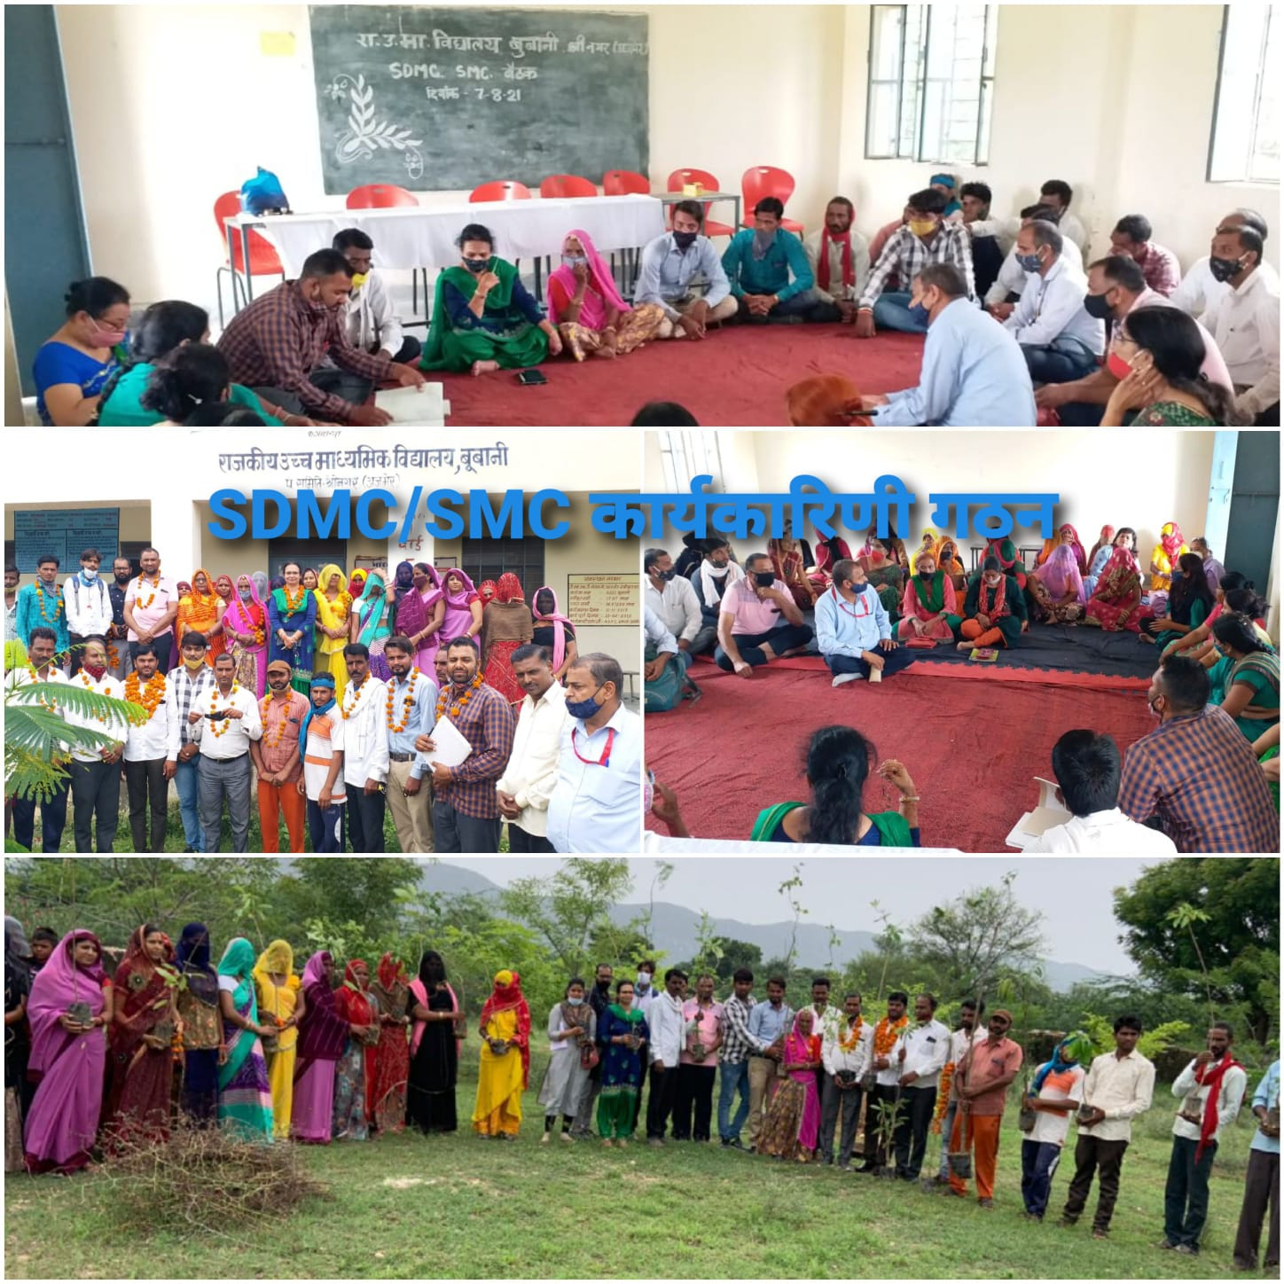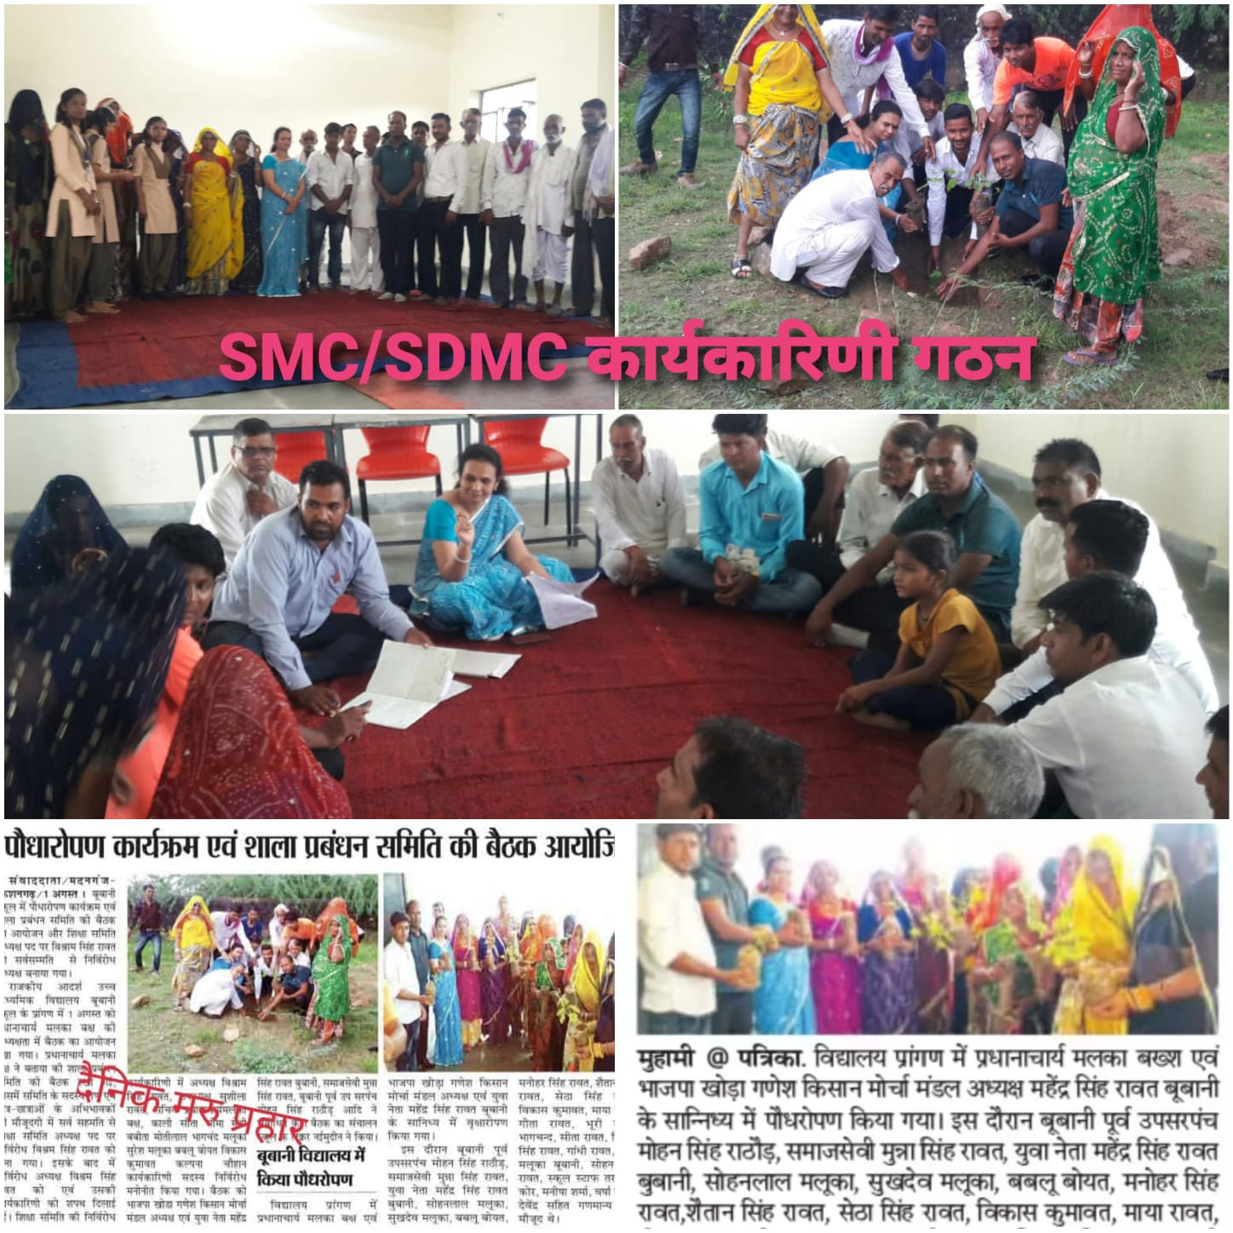
f’k{kd&vfHkHkkod cSBd

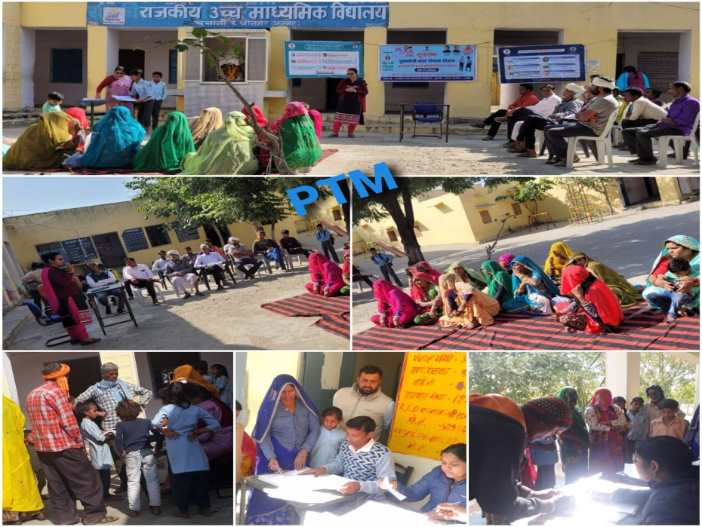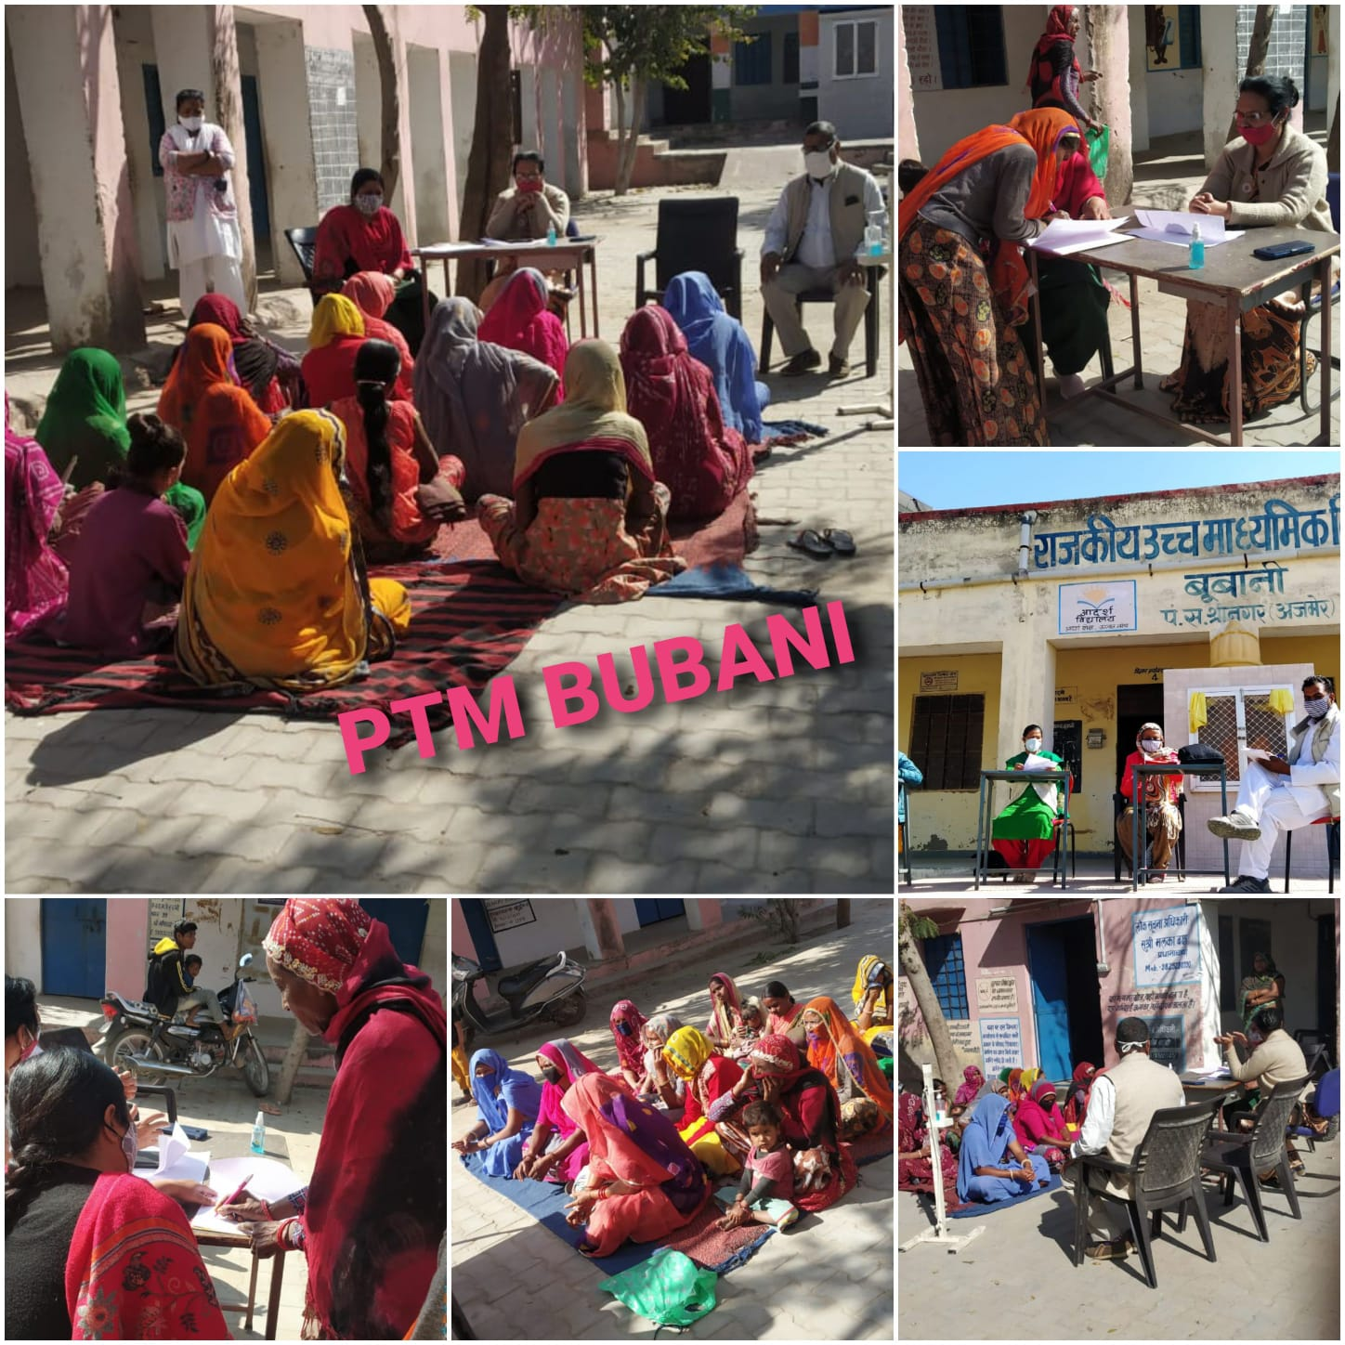

fo|ky; fodkl ,oa izca/ku lfefr izf’k{k.k
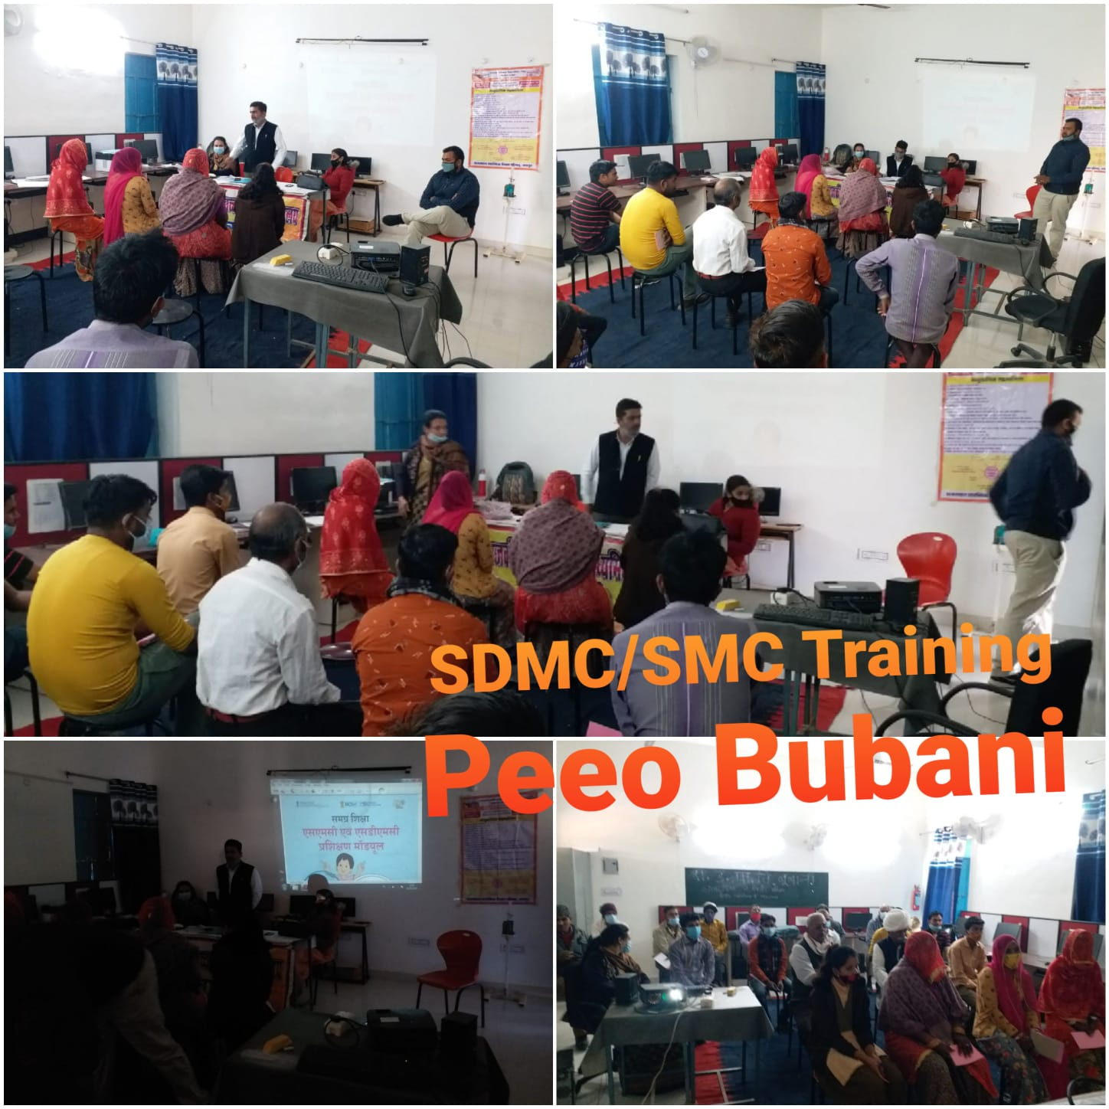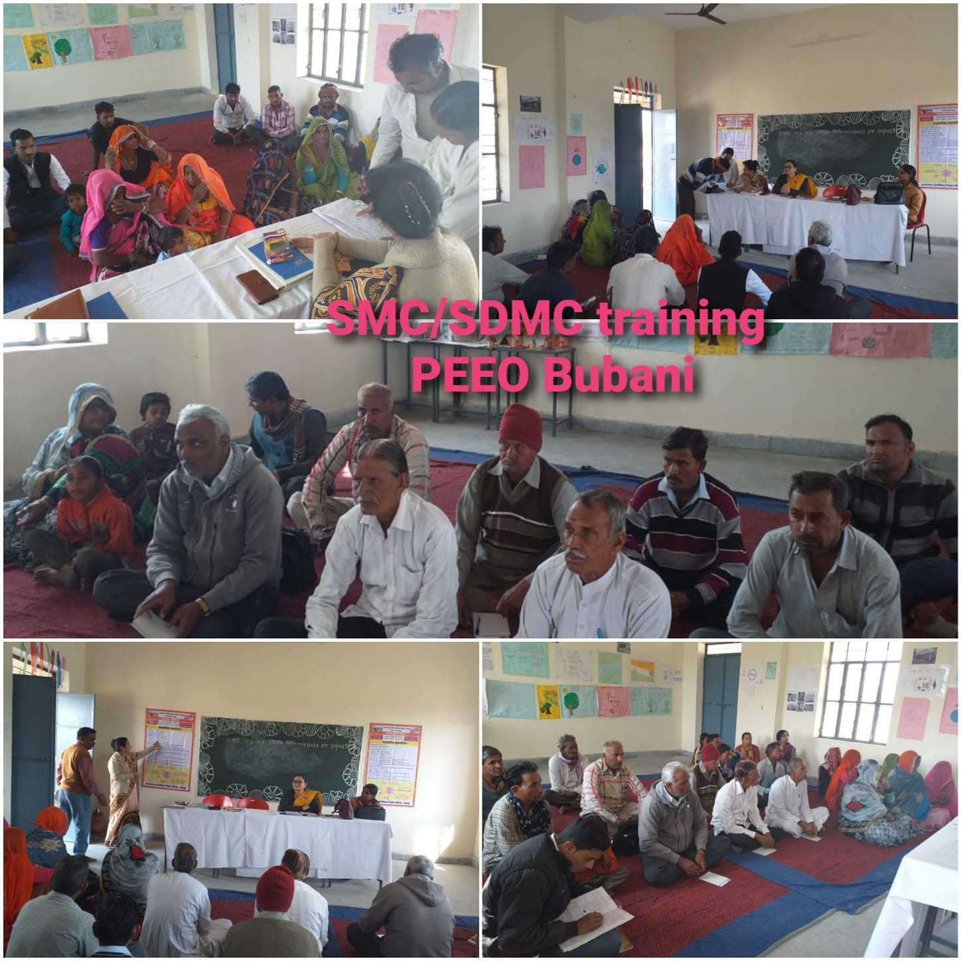
fo|ky; fodkl ,oa izca/ku lfefr }kjk djok, x, fodkl dk;Z
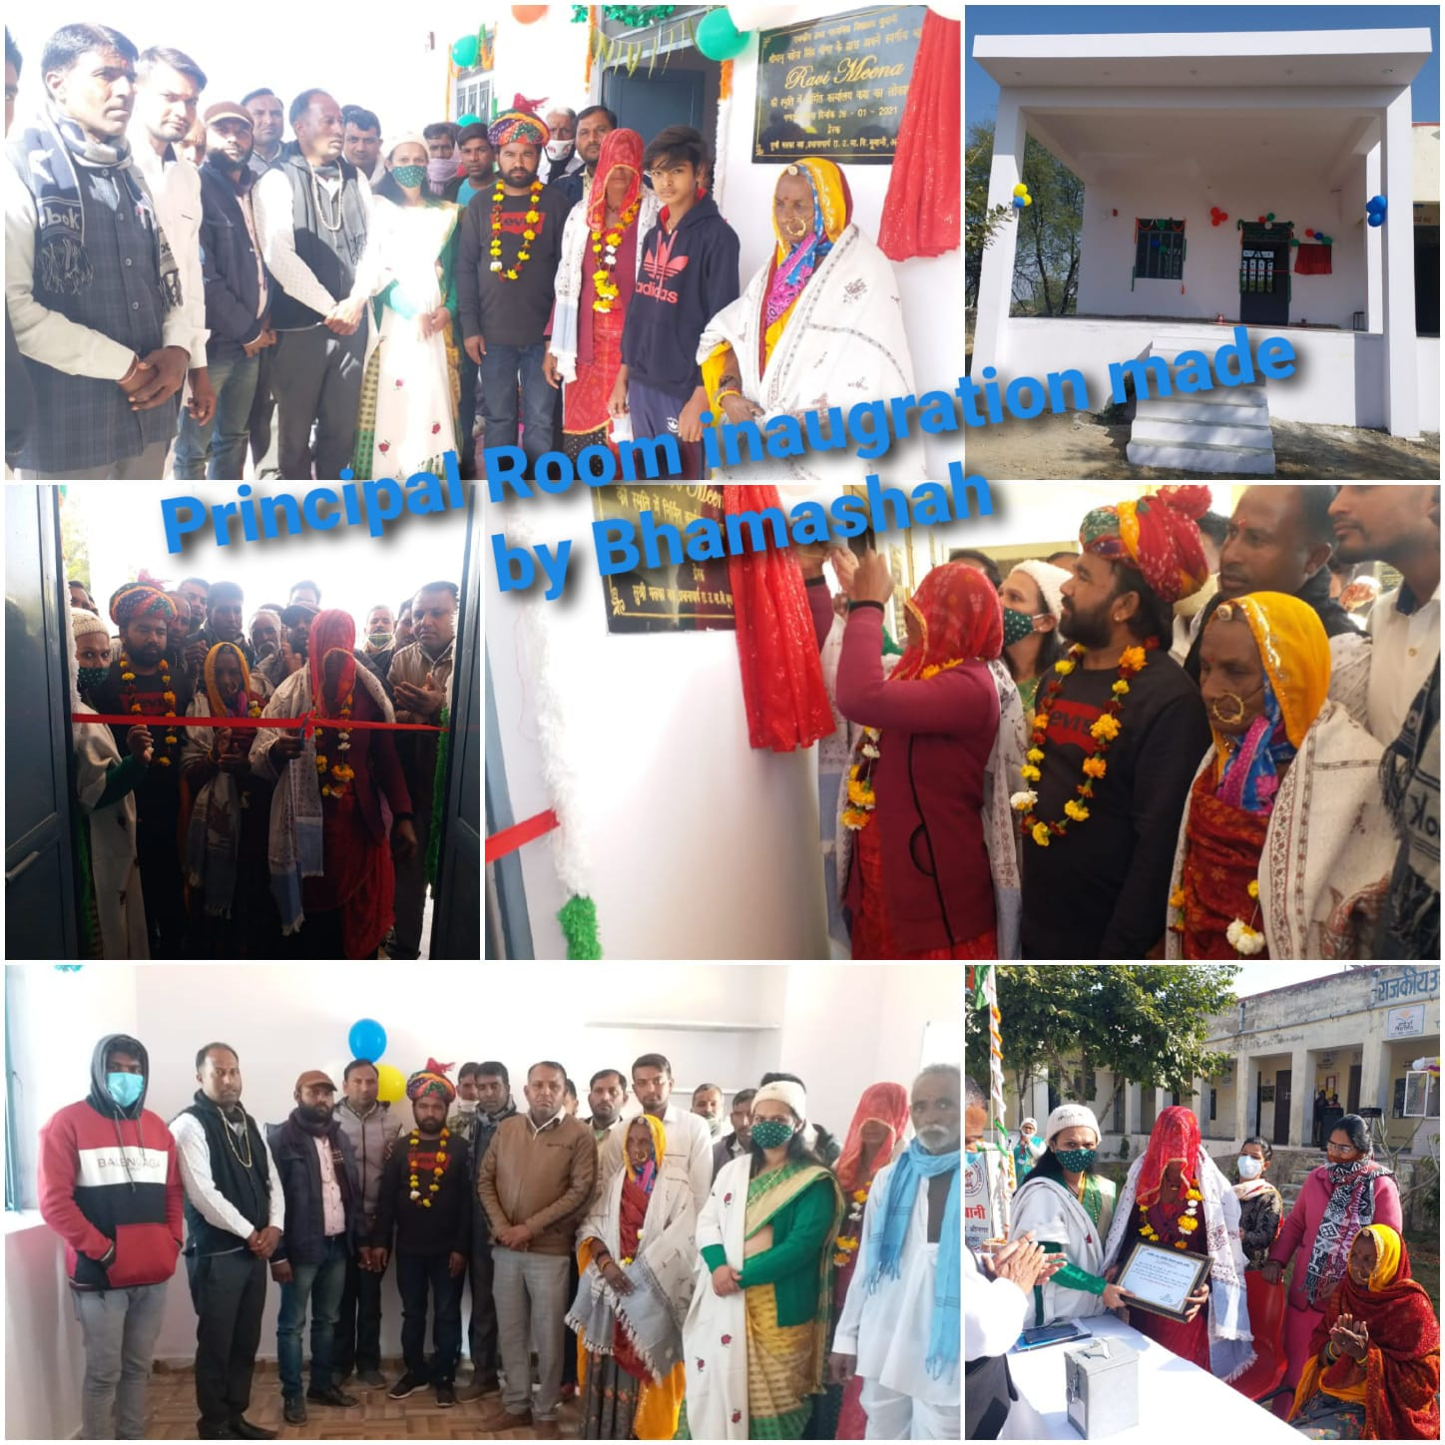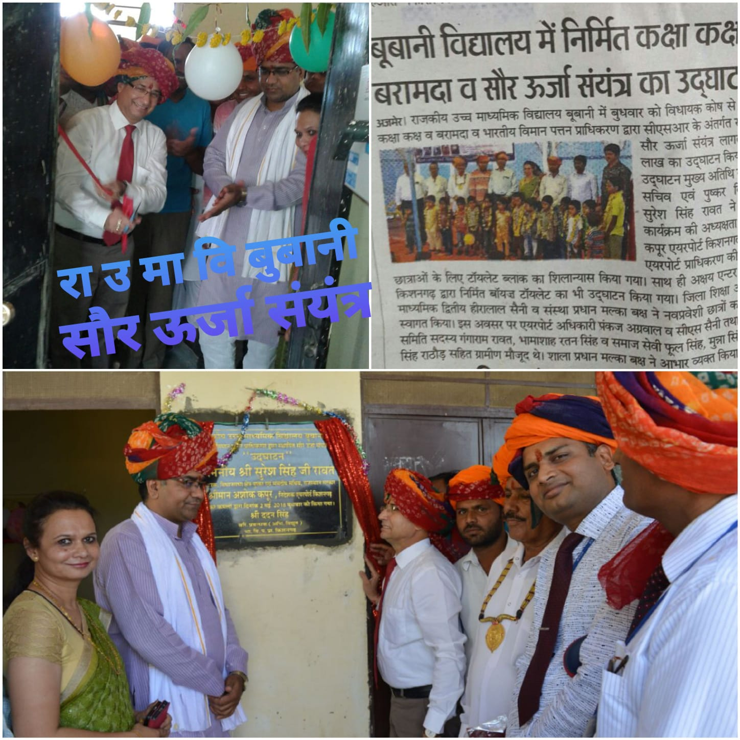

fo|ky; fodkl ,oa izca/ku lfefr }kjk djok, x, fodkl dk;Z
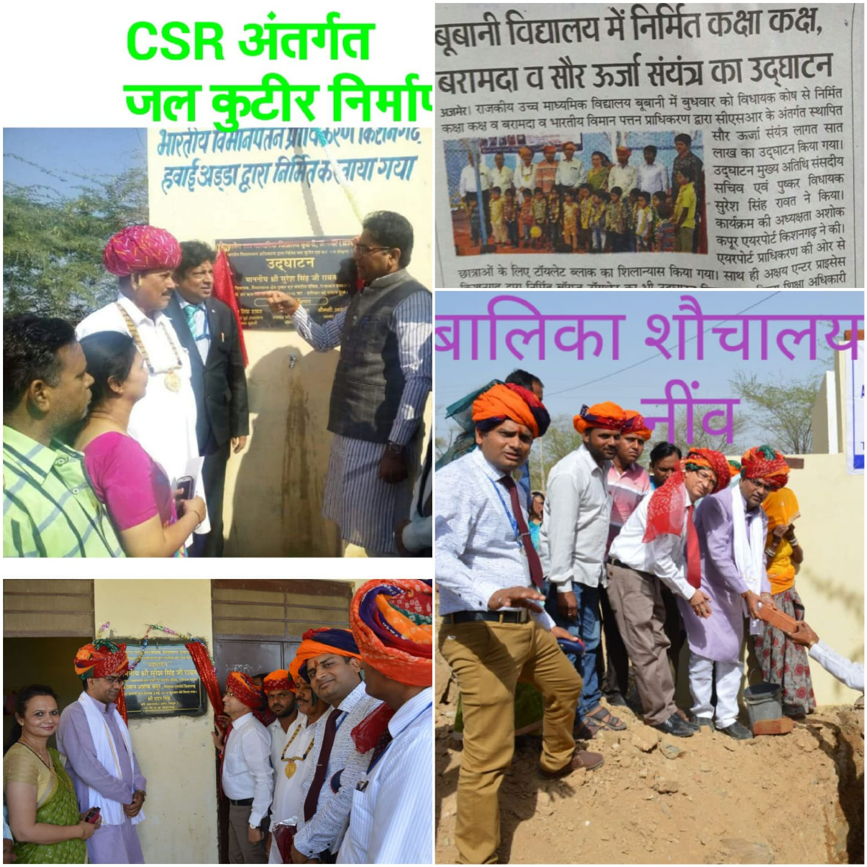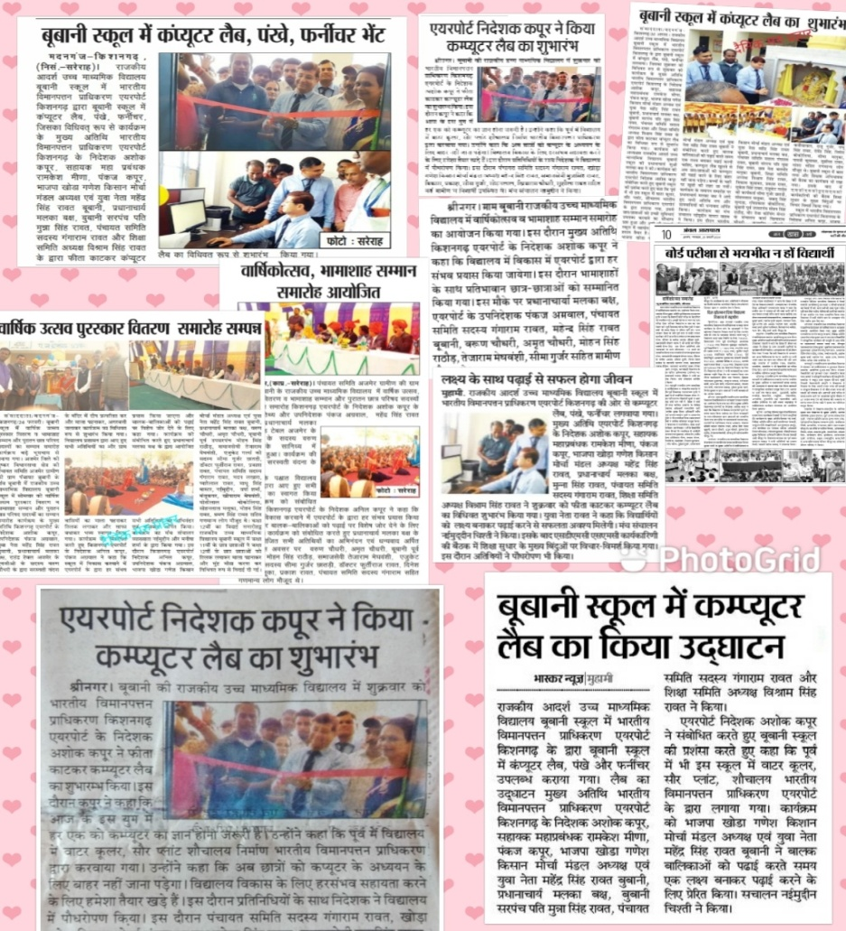
fo|ky; fodkl ,oa izca/ku lfefr }kjk djok, x, fodkl dk;Z
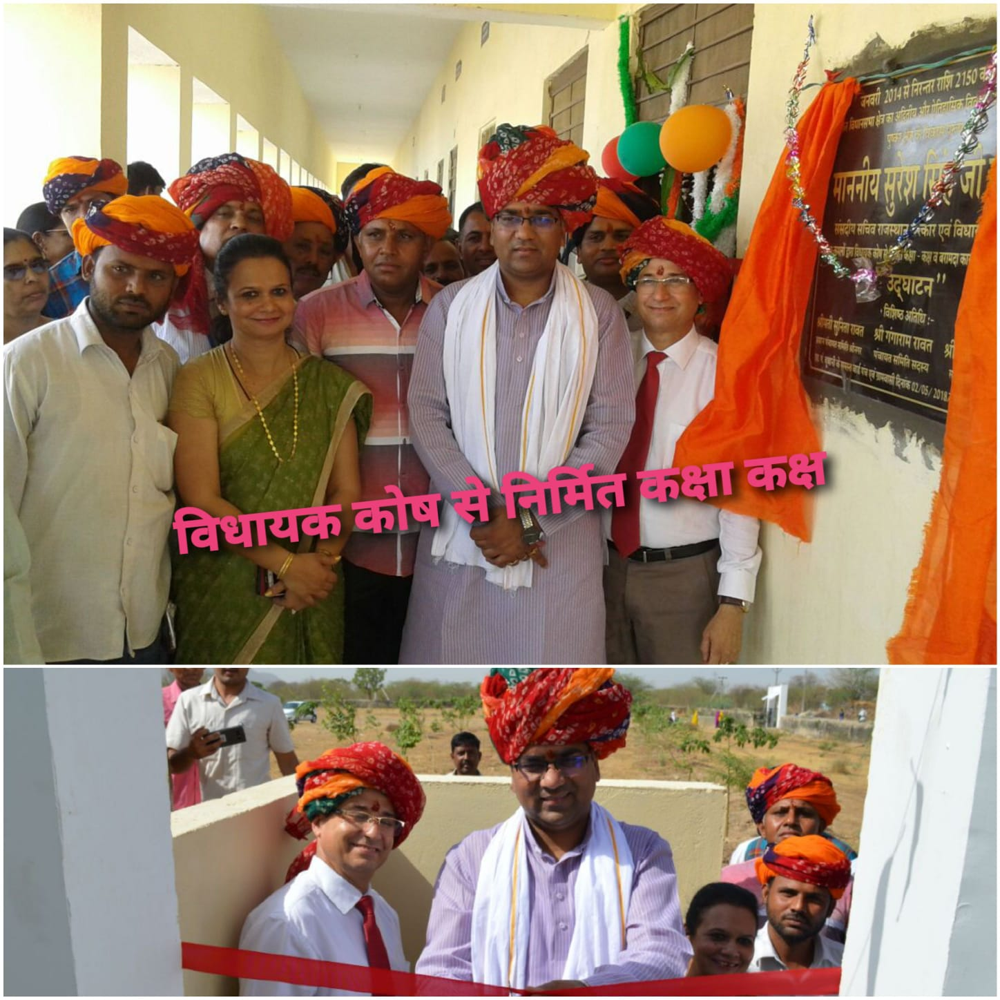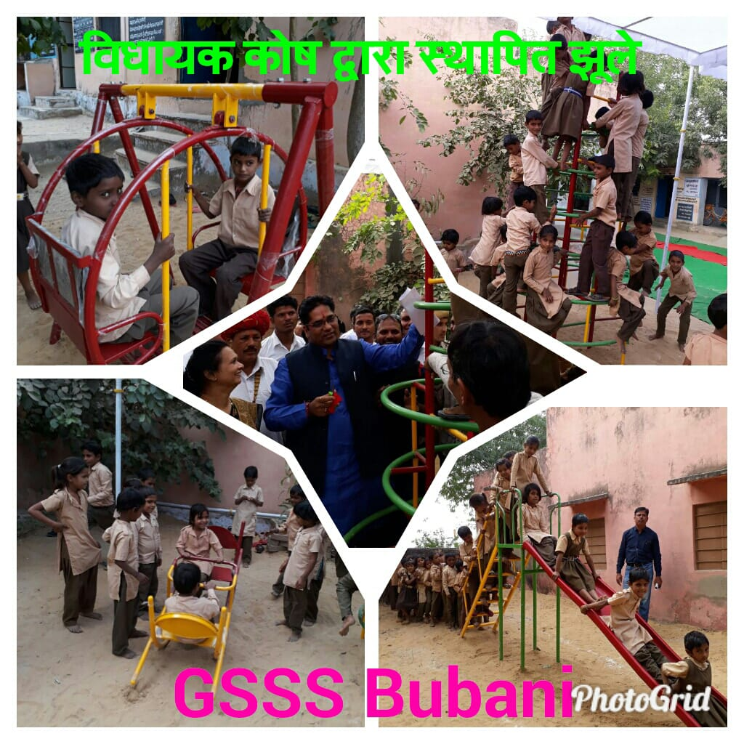

LoPNrk o LokLF; dk;Zdze
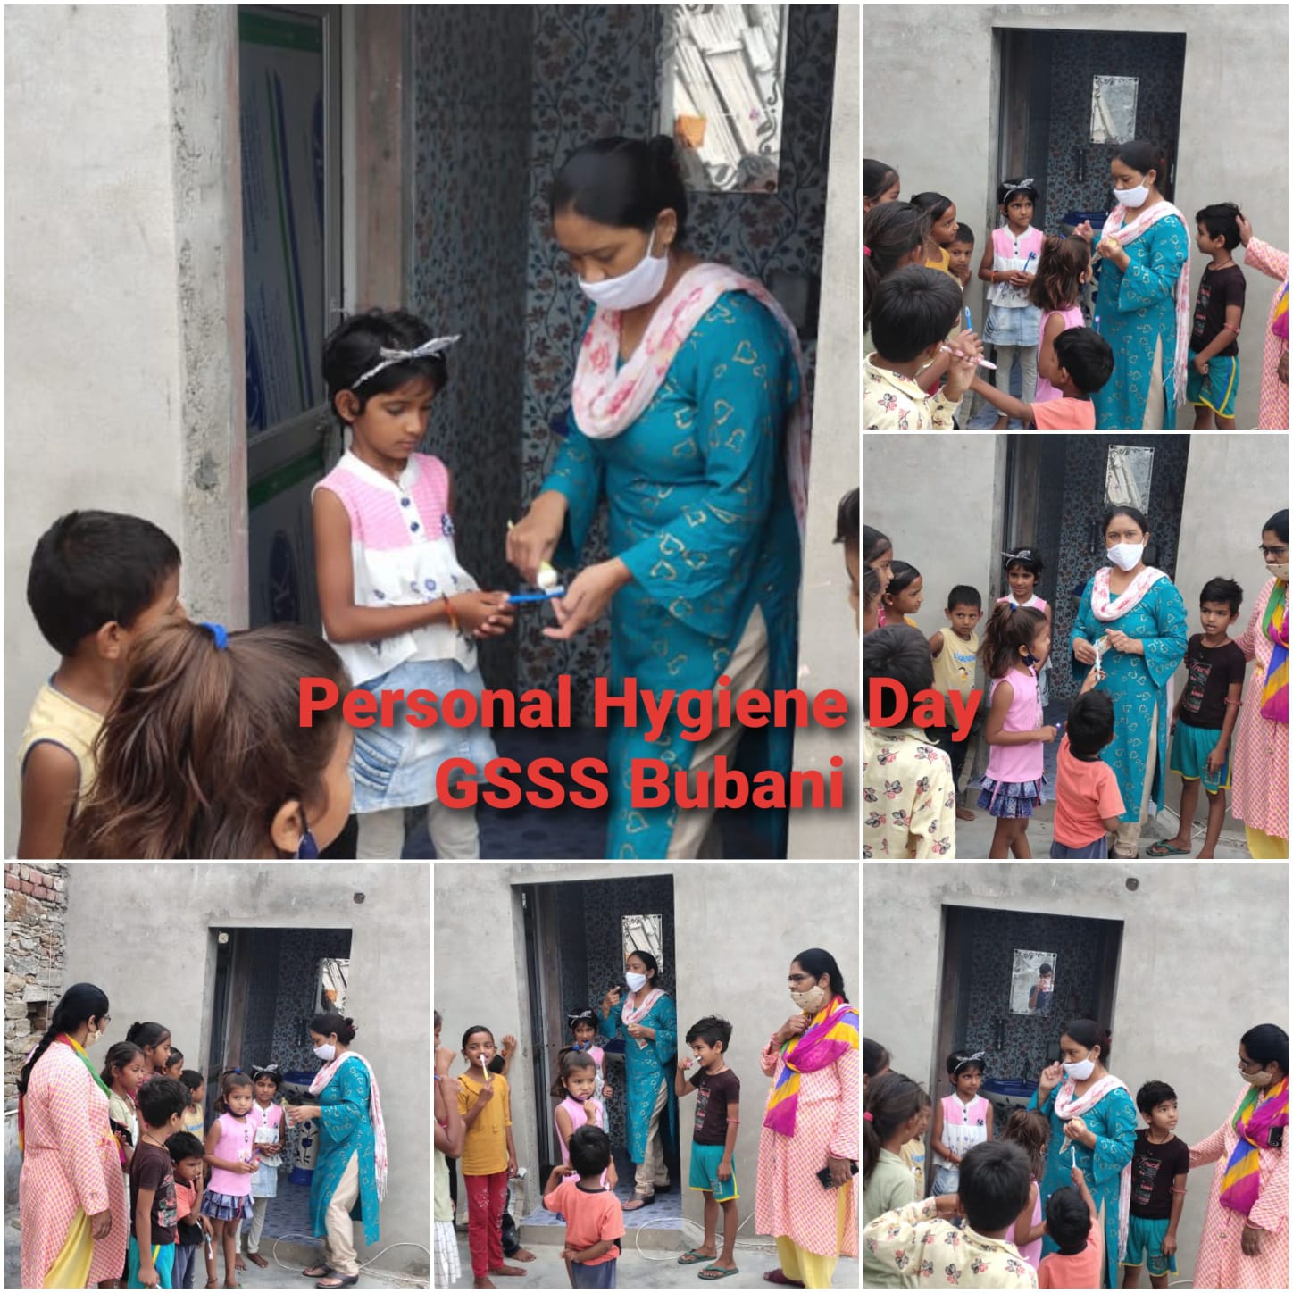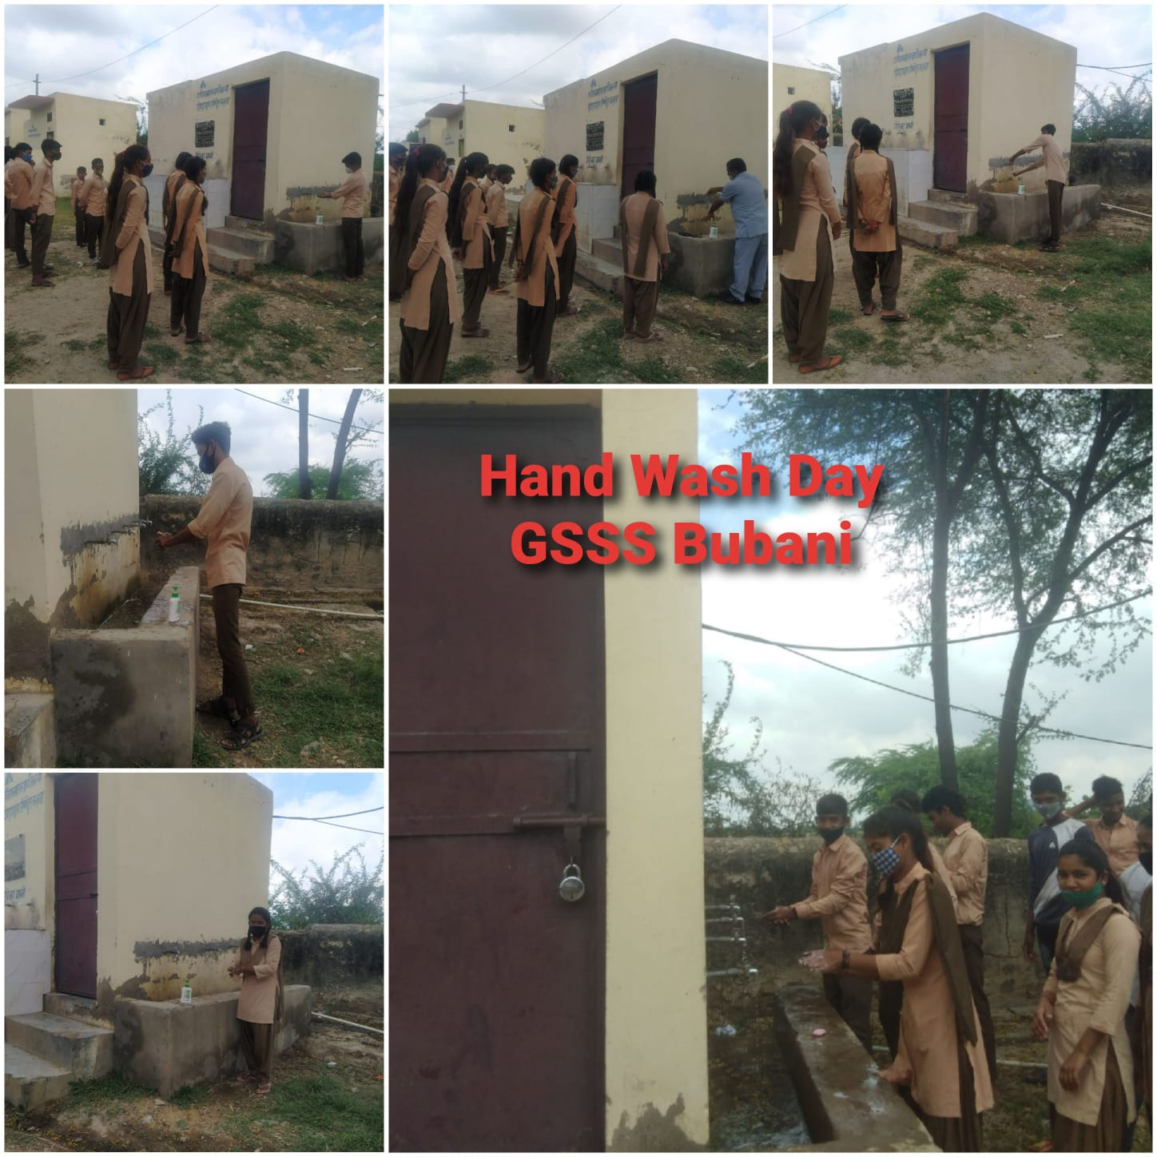

gfjr ikB’kkyk o iks"k.k okfVdk

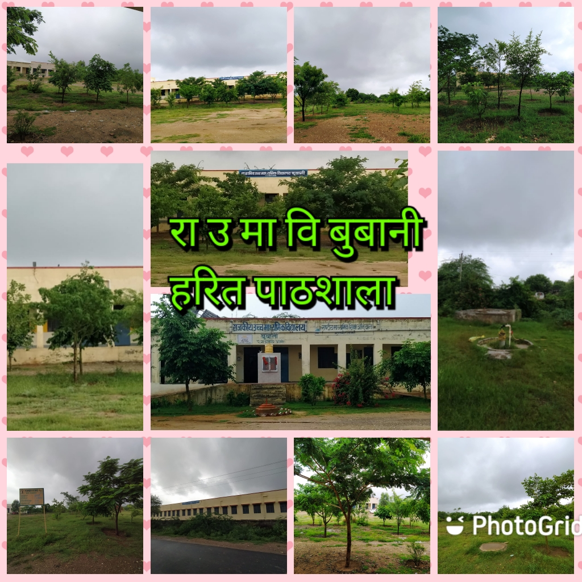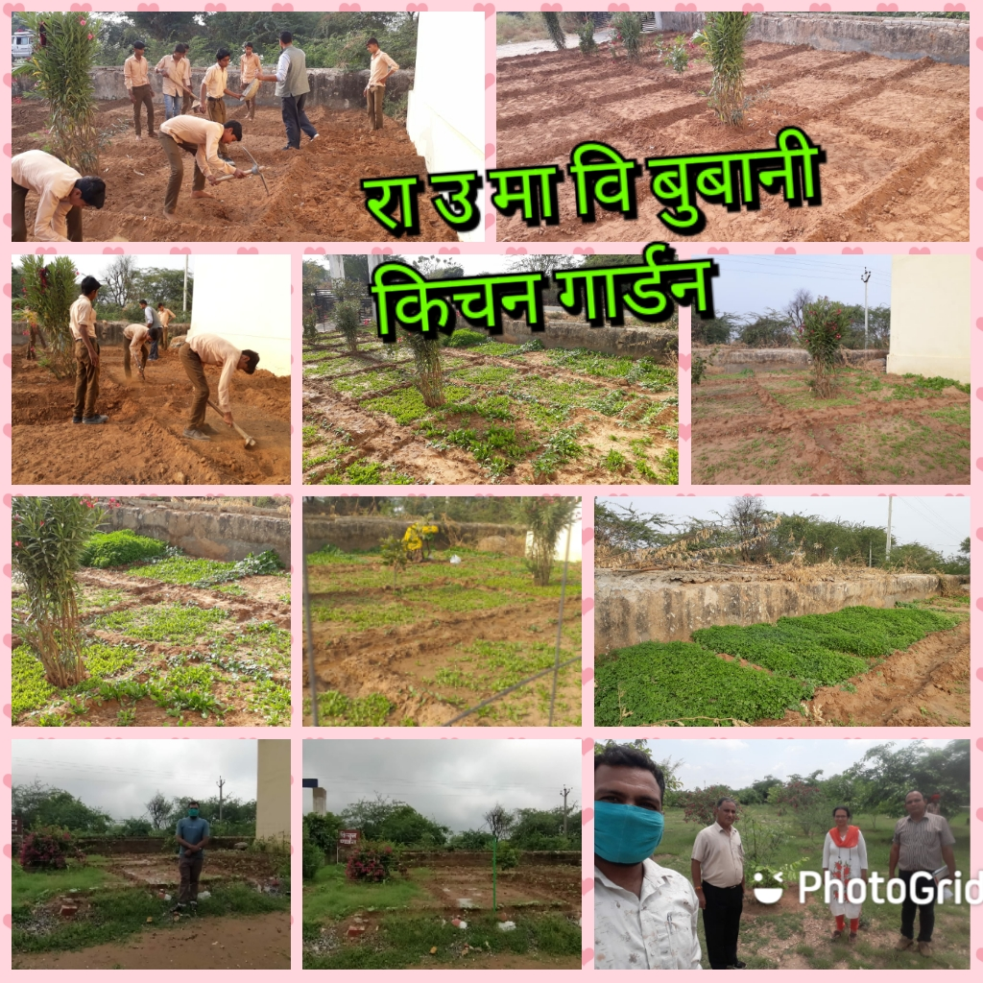
l`tukRed xfrfof/k;ka
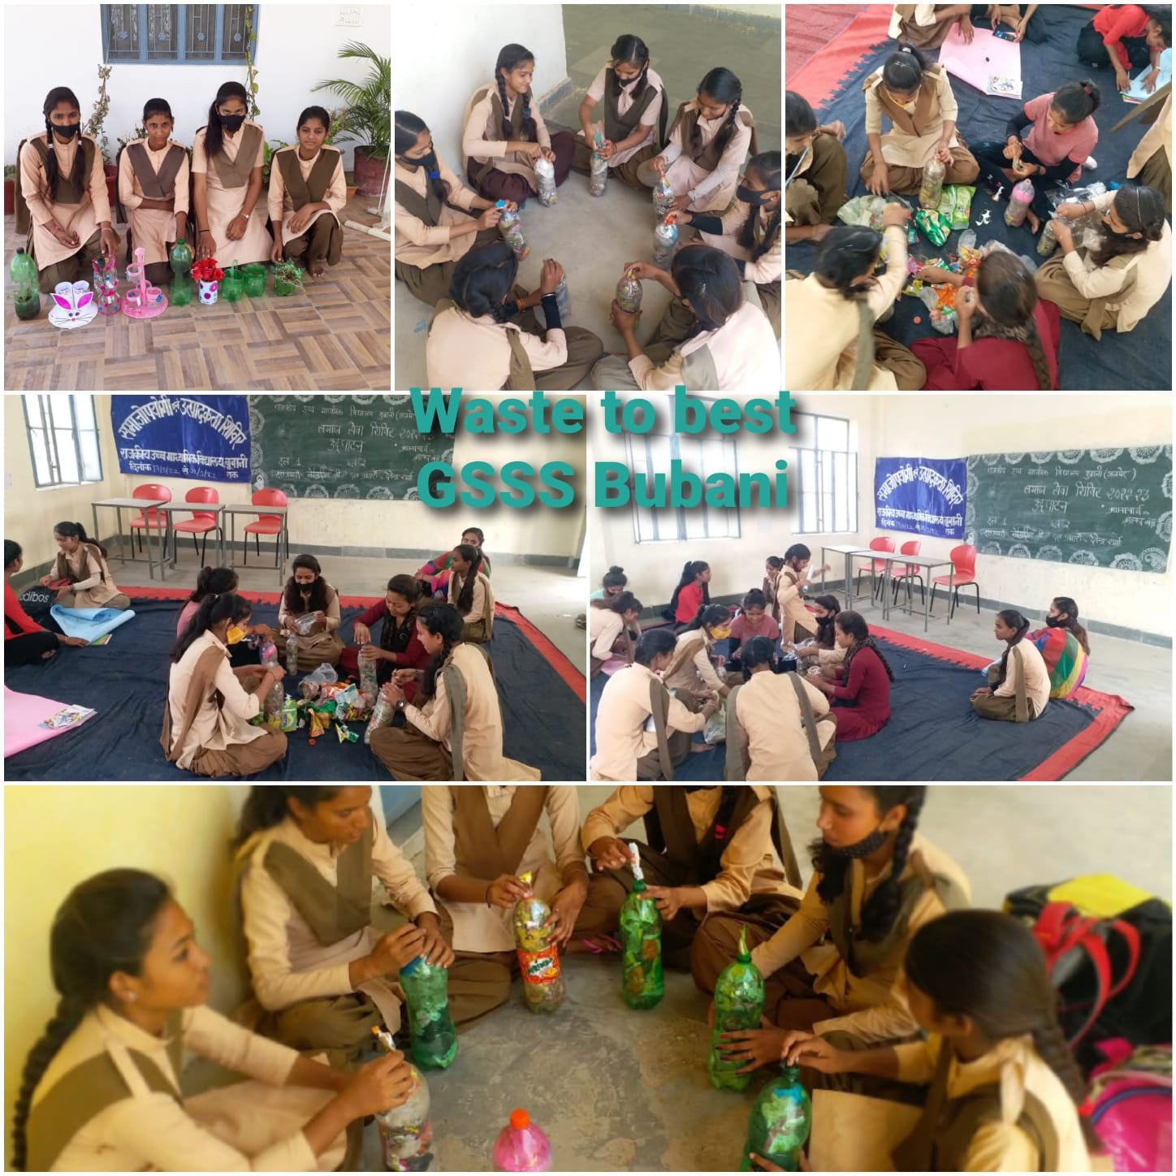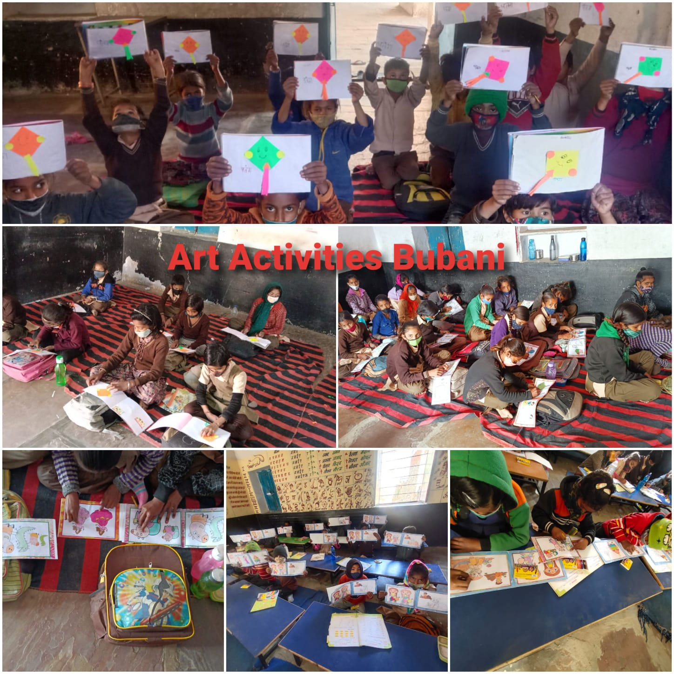
mRlo o t;arh vk;kstu
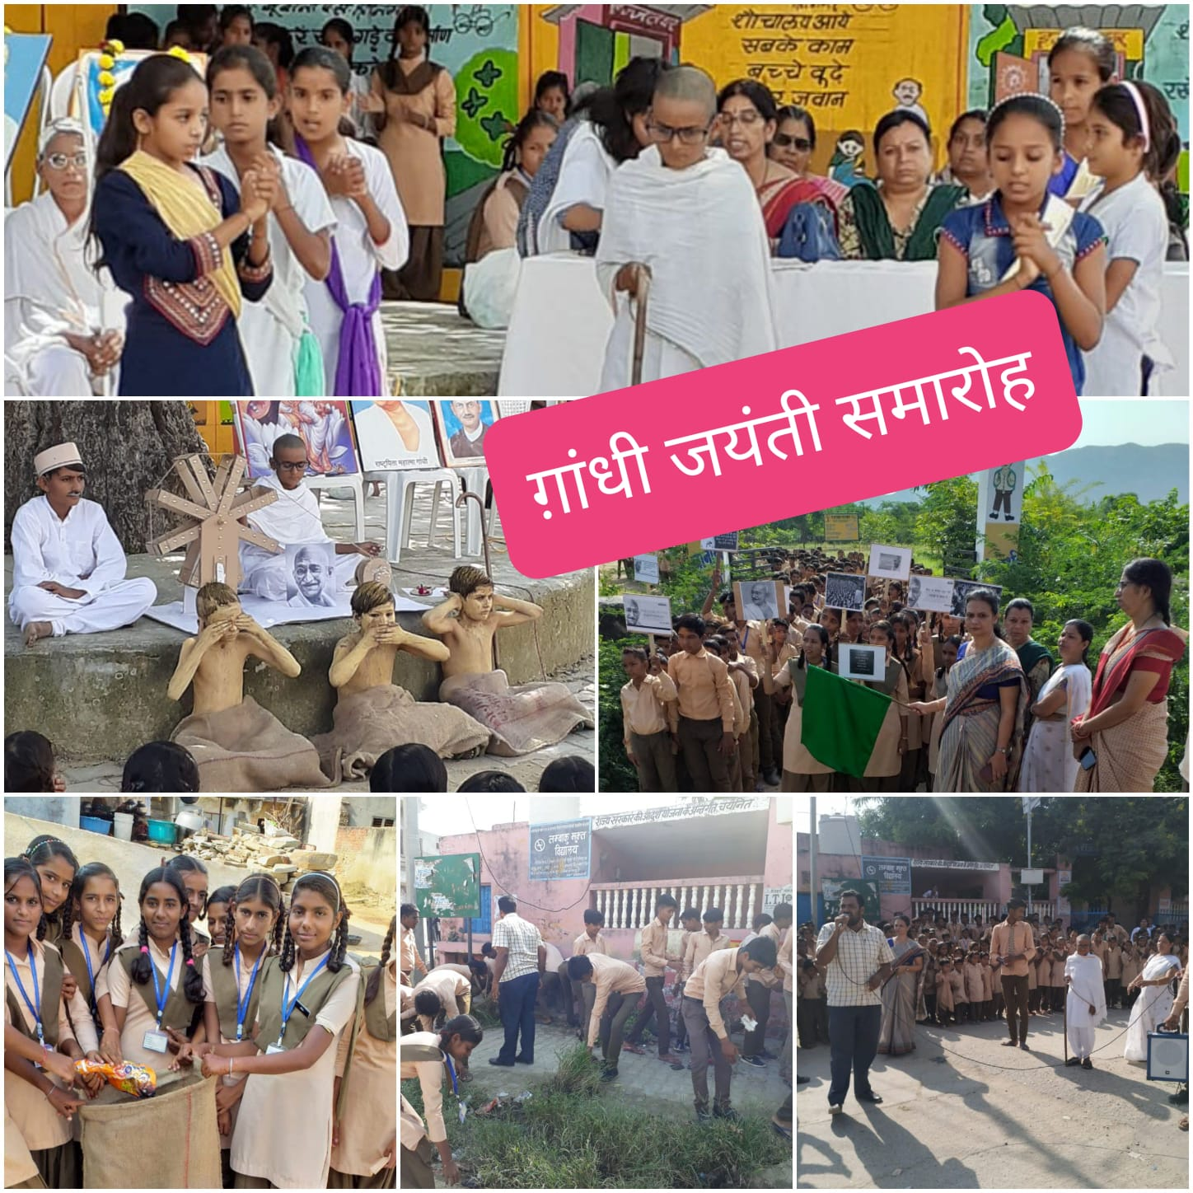
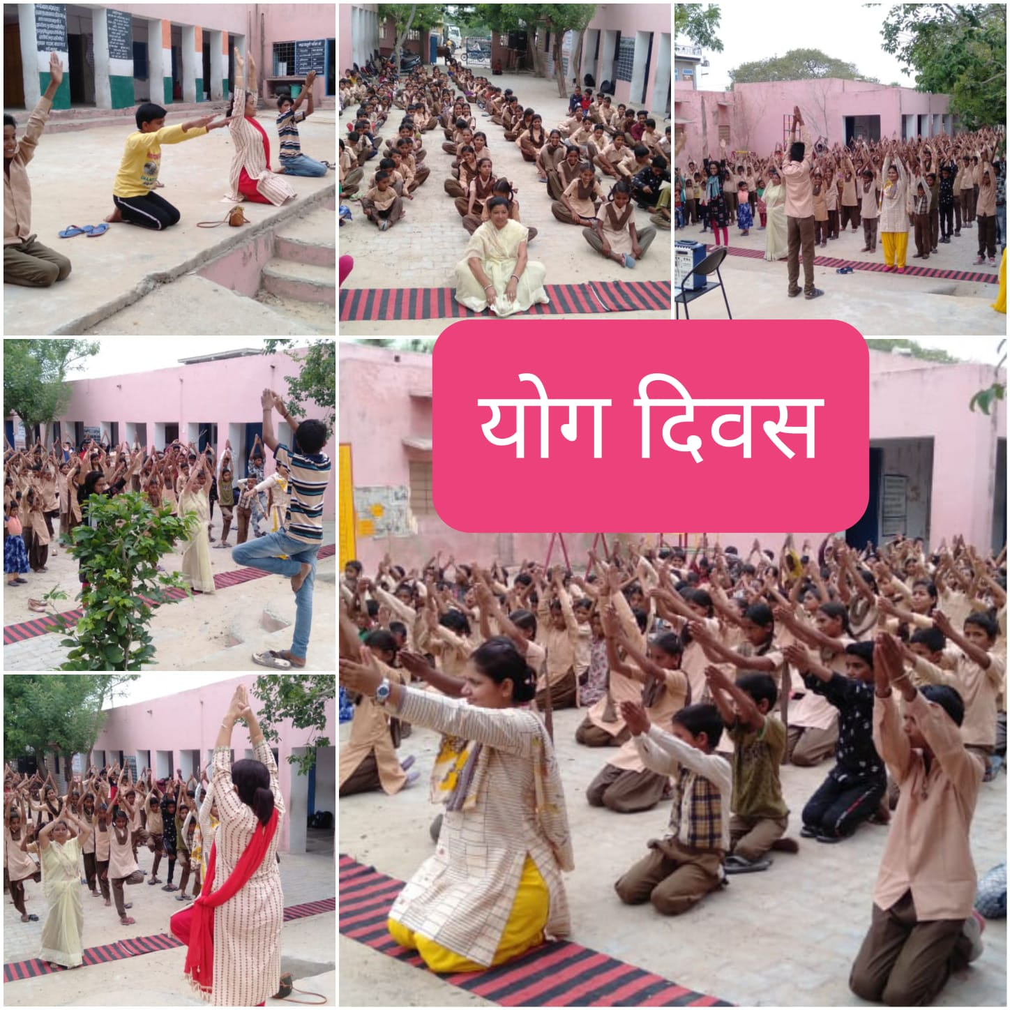
jk"Vªh; dk;ZØeksa dk vk;kstu
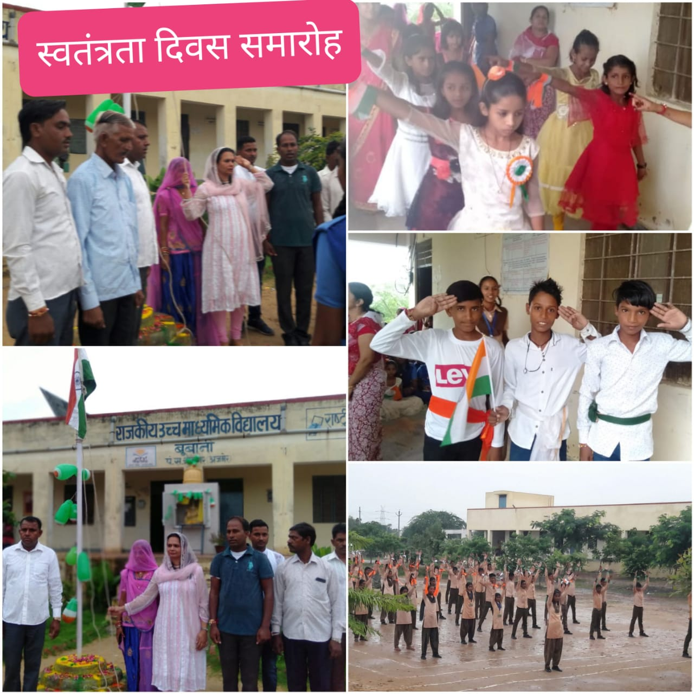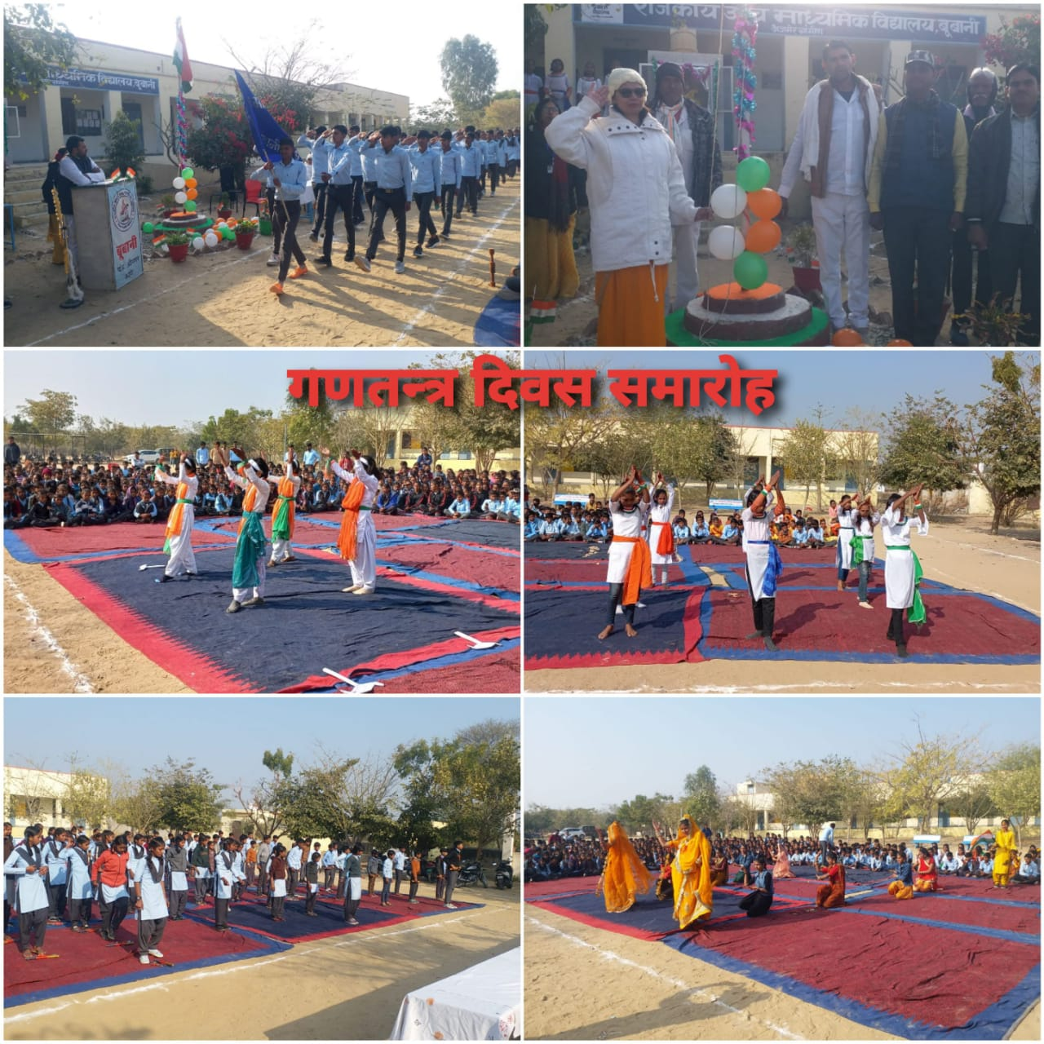
usfr usfr -------!! /kU;okn~!!!

